Assessments of California, Oregon and Washington Stocks of Black Rockfish

(*Sebastes melanops*) in 2015

by

Jason M. Cope, David Sampson, Andi Stephens, Meisha Key, Patrick P. Mirick, Megan Stachura, Tien-Shui Tsou, Phillip Weyland, Aaron Berger, Troy Buell, Elizabeth Councill, E.J. Dick, Kari H. Fenske, Melissa Monk, Brett T. Rodomsky

Northwest Fisheries Science Center

U.S. Department of Commerce

National Oceanic and Atmospheric Administration

National Marine Fisheries Service

2725 Montlake Boulevard East

Seattle, Washington 98112-2097

3/31/2016

**Table of Contents**

Assessments of California, Oregon and Washington Stocks of Black Rockfish 1

Table of Contents 2

Executive Summary 4

Stock 4

Catches 4

Data and assessment 8

Spawning stock output 9

Recruitment 14

Exploitation status 16

Ecosystem considerations 21

Reference points 21

Management performance 25

Unresolved problems and major uncertainties 26

Harvest projections and decision tables 26

Research and data needs 32

Introduction 36

1.1 Basic Information 36

1.2 Life History 37

1.3 Ecosystem Considerations 38

1.4 Fishery Information 38

1.5 Summary of Management History 38

1.6 The Historical Fishery 40

1.7 Management Performance 41

1.8 Fisheries off Canada and Alaska 41

2 Assessment 42

2.1 Data 42

2.1.1 Commercial Fishery Landings 42

2.1.2 Sport Fishery Removals 48

2.1.3 Estimated Discards 52

2.1.4 Biological Parameters and Data 53

2.1.5 Size and Age Composition Data 55

2.1.6 Abundance Indices 62

2.2 History of Modeling Approaches Used for this Stock 72

2.2.1 Black Rockfish South of Cape Falcon 72

2.2.2 Black Rockfish North of Cape Falcon 72

2.2.3 Response to 2007 STAR Panel Recommendations, South of Cape Falcon Assessment 73

2.2.4 Response to 2007 STAR Panel Recommendations, North of Cape Falcon Assessment 74

2.3 Model Description 75

2.3.1 Modeling framework 75

2.3.2 Fleet and survey designations 75

1.1.1 Model likelihood components 76

2.3.3 Model tuning 76

2.3.4 Model parameterization 77

2.4 Model Selection and Evaluation 77

2.4.1 Key assumptions and structural choices 77

2.4.2 Alternative model considerations 78

2.4.3 Model convergence 78

2.5 California Model 78

2.5.1 California Base Model Results 78

2.5.2 California Uncertainty and Sensitivity Analysis 79

2.5.3 California Likelihood Profiles 80

2.5.4 California Retrospective Analysis 80

2.5.5 California Reference Points 80

2.6 Oregon Model 81

2.6.1 Response to July 2015 STAR Panel Recommendations 81

2.6.2 Model Selection and Evaluation 82

2.6.3 Oregon Base Model Results 83

2.6.4 Oregon Uncertainty and Sensitivity Analyses 84

2.6.5 Oregon Likelihood Profiles 85

2.6.6 Oregon Retrospective Analysis 85

2.6.7 Oregon Reference Points 85

2.7 Washington Model 85

2.7.1 Washington Base Model Results 85

2.7.2 Washington Uncertainty and Sensitivity Analyses 86

2.7.3 Washington Likelihood Profiles 87

2.7.4 Washington Retrospectives 87

2.7.5 Washington Reference Points 87

3 Harvest Projections and Decision Tables 87

3.1.1 California Projections and Decision Tables 88

3.1.2 Oregon Projections and Decision Tables 88

3.1.3 Washington Projections and Decision Tables 88

4 Regional Management Considerations 88

5 Research Needs 89

6 Acknowledgments 90

7 Literature Cited 90

8 Tables 95

8.1 Tables Common to All Assessments 95

8.2 CA Tables 99

8.3 OR Tables 115

8.4 WA Tables 138

9 Figures 157

9.1 Figures Common to All Assessments 157

9.2 CA Data Figures 168

9.3 CA Model Figures 179

9.4 OR Data Figures 233

9.5 OR Model Figures 248

9.6 WA Data Figures 327

9.7 WA Model Figures 344

Executive Summary

Stock

The assessments described in this document apply to the black rockfish (*Sebastes melanops*) stocks that reside in the waters from Point Conception (34°27' N latitude) in the south to the U.S. boundary with Canada (approximately 48°30' N latitude). Following the consensus recommendations from a preliminary stock assessment workshop in April 2015 (PFMC 2015), the stock assessment team (STAT) decided to prepare separate geographic stock assessments that are spatially stratified with boundaries at the CA/OR border (42°00' N latitude) and OR/WA border (46°16' N latitude).

Black rockfish are also caught from the waters off British Columbia and Alaska, but there have not been any formal assessments of stock status for those areas.

Catches

Black rockfish are caught by a wide variety of gear types and in recent decades have been a very important target species for recreational charter-boats and private sport anglers in Washington and Oregon, and to a lesser extent in California. In recent years the recreational fishery has accounted for most of the black rockfish catches (Figure ES-1 to Figure ES-3). Black rockfish can also be an important component of nearshore commercial fisheries, either as incidental catch by the troll fishery for salmon or as directed catch by jig fisheries for groundfish. Further, in California and Oregon there are nearshore fisheries that catch and sell fish live for the restaurant trade. Washington closed nearshore commercial fisheries in state water in late 1990’s and never allowed the live-fish fishery to develop. In all states there have been almost no trawl-caught landings of black rockfish in recent years (Table ES-1), but trawl landings in the past were substantial (Figure ES-1 to Figure ES-3).

Detailed reports of commercial landings of black rockfish are generally unavailable prior to 1981, when the Pacific Fishery Information Network (PacFIN) database began. The catch series prior to 1981 for these assessments were derived by applying available estimates or assumed values for the proportion of black rockfish landings in reported landings of rockfish. Observer data, which are available only for the past decade, indicate low levels of discarding of black rockfish, generally less than 2% of total catch.

Because of their nearshore distribution and low abundance compared to other rockfish species, black rockfish are unlikely to have ever comprised a large percentage of rockfish landings, but it seems quite certain that they have been more than a trivial component for many years. Black rockfish were one of only four rockfish species mentioned by scientific name in reports of rockfish landings in Oregon during the 1940s, and they were one of only six rockfish species mentioned by scientific name in reports of rockfish landings in California during the same period. Mentions of black rockfish extend back before the year 1900 in Washington.

Table ES-1: Recent black rockfish removals by state.

|  |  |  |  |  |  |
| --- | --- | --- | --- | --- | --- |
|  | Removals in mt | | | | |
| Year | WA rec | OR comm | OR rec | CA comm | CA rec |
| 2005 | 325 | 100 | 327 | 74 | 187 |
| 2006 | 312 | 95 | 281 | 63 | 199 |
| 2007 | 286 | 103 | 272 | 85 | 152 |
| 2008 | 222 | 100 | 253 | 85 | 168 |
| 2009 | 251 | 136 | 310 | 94 | 271 |
| 2010 | 219 | 102 | 318 | 52 | 217 |
| 2011 | 231 | 98 | 221 | 27 | 192 |
| 2012 | 281 | 98 | 233 | 22 | 221 |
| 2013 | 325 | 108 | 328 | 35 | 385 |
| 2014 | 355 | 124 | 362 | 41 | 361 |

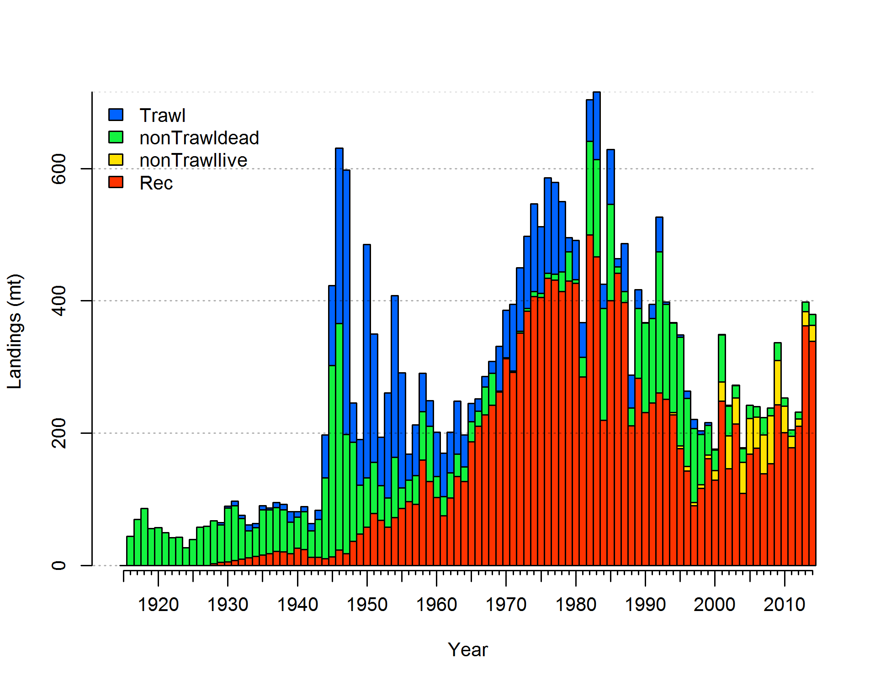

Figure ES-1. Landings history of black rockfish for California.

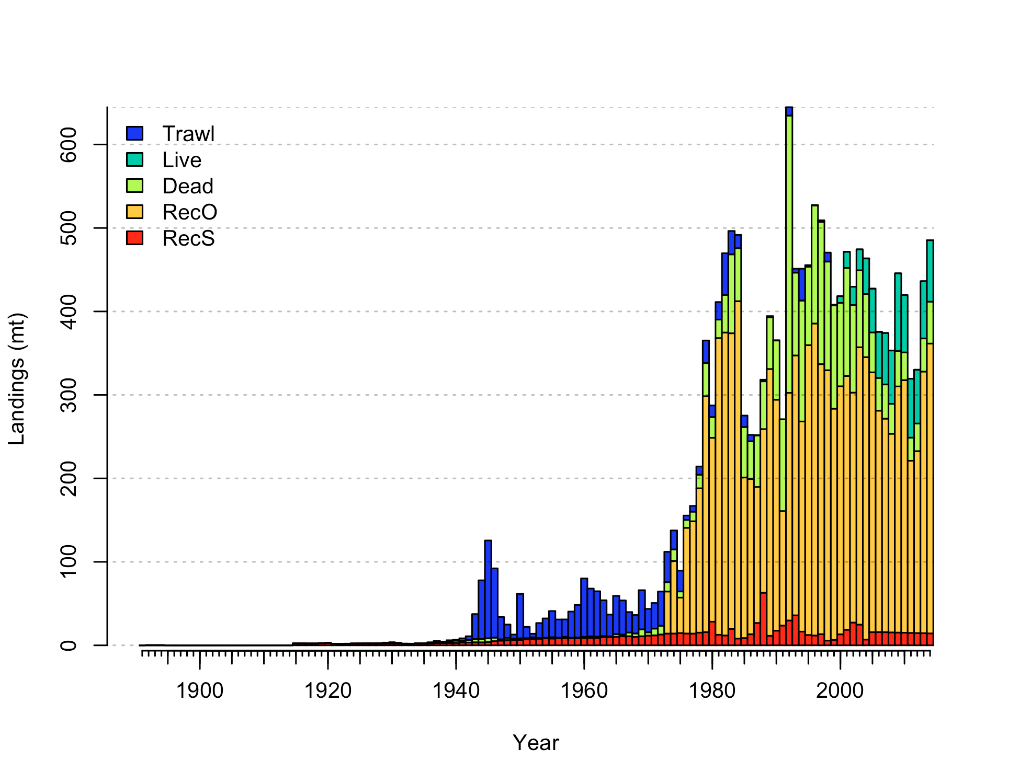

Figure ES-2. Landings history of black rockfish for Oregon.

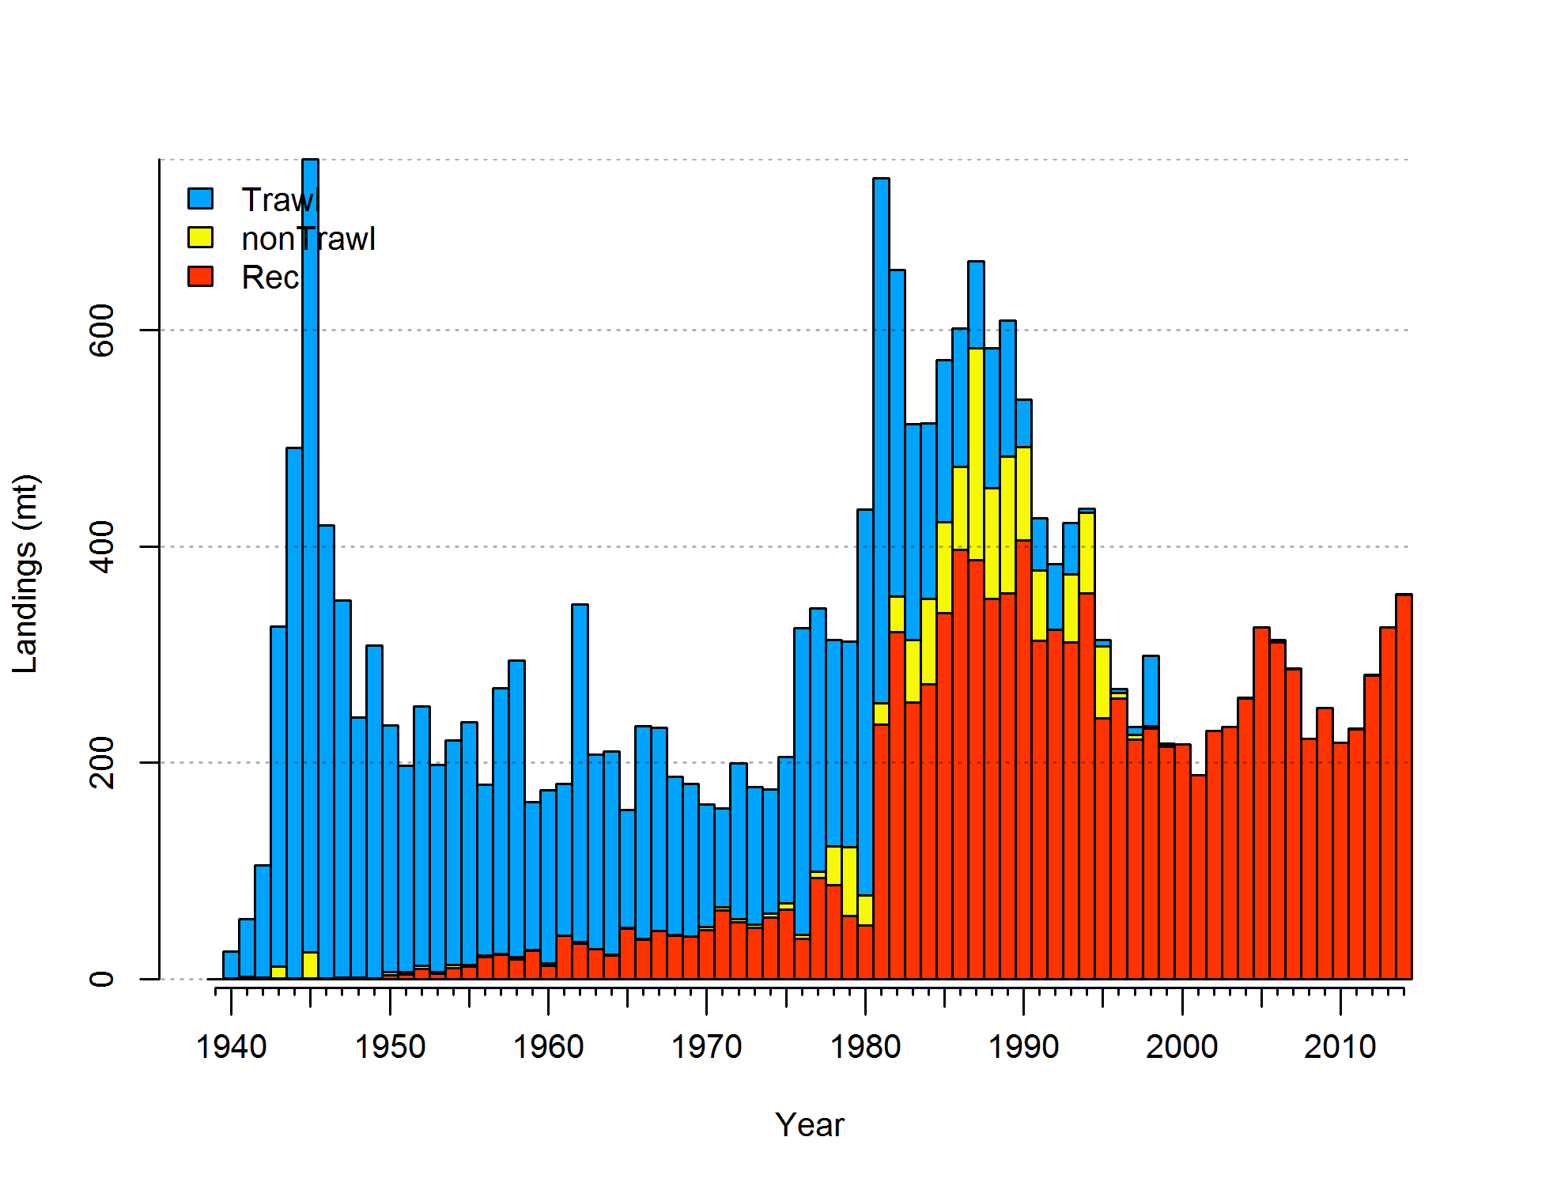

Figure ES-3. Landings history of black rockfish for Washington.

Data and assessment

The last stock assessments for black rockfish were conducted in 2007 for areas north and south of Cape Falcon (45°46´ North latitude). The current assessments assume three areas instead of two, delineated by the state lines as was agreed upon at a pre-assessment and data workshop in March 2015. The prior assessments used Stock Synthesis 2, while the current assessments use Stock Synthesis 3. The Washington base assessment includes a dockside and tag-based CPUE series, but does not include the abundance estimate time series from that same tagging study which was included in the last assessment due to too many violations in the assumptions of abundance estimation. The same two commercial and single recreational fleets are used as in the last assessment for Washington. The Oregon assessment has three commercial fleets and two recreational fleets, while using five surveys and an additional research study for biological compositions. California also has three commercial fleets and 1 recreational fleet with three surveys of abundance, all based on recreational fisheries. All area models include age data as conditional age at lengths. Length compositions are also included in all models.

Spawning stock output

Spawning stock outputs are all at or above limit reference points (Table ES-2. Only California shows declines significantly below this reference point at any point in the time series. California and Washington stocks show a declining population through most of the 20th Century, with stronger declines in the 1980s, and recoveries beginning in the mid-1990s. Oregon stocks follow this pattern, but with a decline in the most recent period. California (33%) is below the target biomass reference point with an increasing biomass trend (Figures ES-4 and ES-5). The Oregon stock dropped after the quick ramp up of catches in the late 1970s and continued a steady decline until around year 2000, settling in at a stock status around 60% of initial conditions. The Washington stock, currently 43%, dropped below the target biomass by in the early 1980s, then risen above since the late 1990s and has fluctuated above that point through 2014 (Figures ES-8 and ES-9).

Table ES-2: Recent trend in beginning of the year biomass and depletion for black rockfish by assessment area.

|  |  |  |  |  |  |  |  |  |  |  |  |  |  |  |  |  |  |
| --- | --- | --- | --- | --- | --- | --- | --- | --- | --- | --- | --- | --- | --- | --- | --- | --- | --- |
|  | California | | | | |  | Oregon | | | | |  | Washington | | | | |
| Year | Spawning | ~95% |  | Estimated | ~95% |  | Spawning | ~95% |  | Estimated | ~95% |  | Spawning | ~95% |  | Estimated | ~95% |
| Output | confidence | depletion | confidence |  | Output | confidence | depletion | confidence |  | Output | confidence | depletion | confidence |
|  | interval |  | interval |  |  | interval |  | interval |  |  | interval |  | interval |
| 2006 | 228 | 145-311 |  | 0.21 | 0.13-0.3 |  | 817 | 705-929 |  | 59 | 57.6-60.5 |  | 576 | 466-686 |  | 0.42 | 0.35-0.5 |
| 2007 | 231 | 145-317 |  | 0.22 | 0.13-0.31 |  | 819 | 707-931 |  | 59.1 | 57.7-60.6 |  | 564 | 455-672 |  | 0.42 | 0.35-0.49 |
| 2008 | 241 | 151-332 |  | 0.23 | 0.14-0.32 |  | 822 | 710-933 |  | 59.4 | 57.9-60.8 |  | 557 | 449-665 |  | 0.41 | 0.34-0.48 |
| 2009 | 257 | 159-354 |  | 0.24 | 0.14-0.34 |  | 827 | 716-939 |  | 59.8 | 58.4-61.2 |  | 558 | 450-665 |  | 0.41 | 0.34-0.48 |
| 2010 | 268 | 162-374 |  | 0.25 | 0.15-0.36 |  | 826 | 714-938 |  | 59.7 | 58.2-61.1 |  | 551 | 444-657 |  | 0.41 | 0.34-0.47 |
| 2011 | 285 | 170-401 |  | 0.27 | 0.15-0.38 |  | 826 | 714-938 |  | 59.7 | 58.2-61.1 |  | 550 | 444-656 |  | 0.41 | 0.34-0.47 |
| 2012 | 305 | 180-430 |  | 0.29 | 0.17-0.41 |  | 834 | 722-946 |  | 60.2 | 58.8-61.6 |  | 552 | 446-658 |  | 0.41 | 0.34-0.47 |
| 2013 | 322 | 189-454 |  | 0.30 | 0.17-0.43 |  | 842 | 729-954 |  | 60.8 | 59.4-62.2 |  | 557 | 449-664 |  | 0.41 | 0.34-0.48 |
| 2014 | 329 | 191-468 |  | 0.31 | 0.18-0.44 |  | 841 | 729-954 |  | 60.8 | 59.4-62.2 |  | 567 | 456-678 |  | 0.42 | 0.35-0.49 |
| 2015 | 353 | 204-503 |  | 0.33 | 0.19-0.48 |  | 836 | 723-949 |  | 60.4 | 58.9-61.8 |  | 582 | 467-698 |  | 0.43 | 0.36-0.5 |

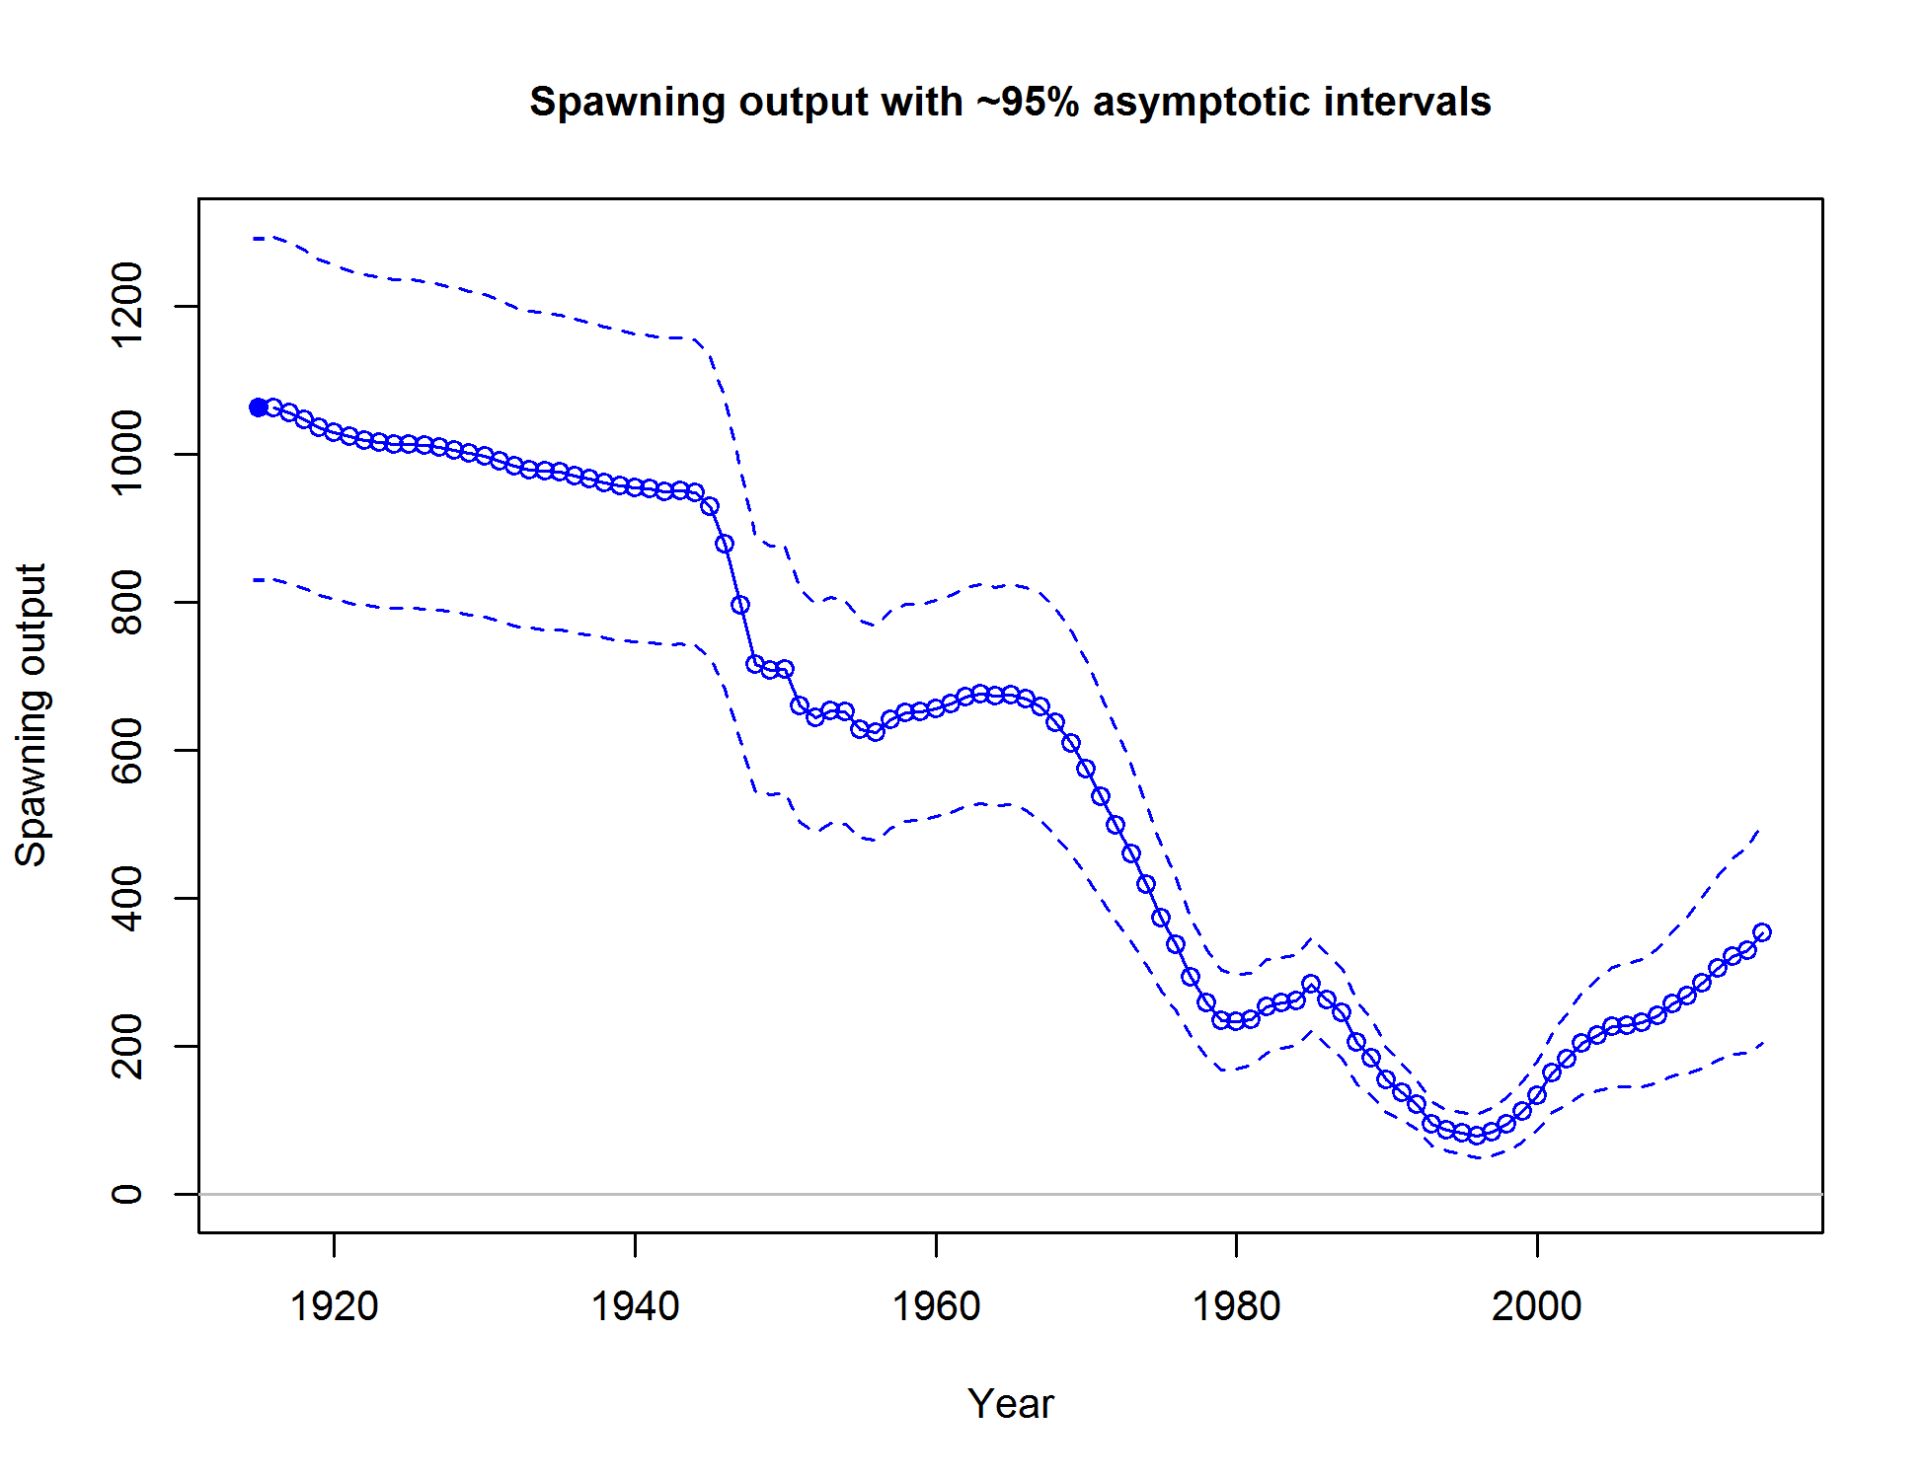

Figure ES-4. Time series of spawning output of black rockfish in California.

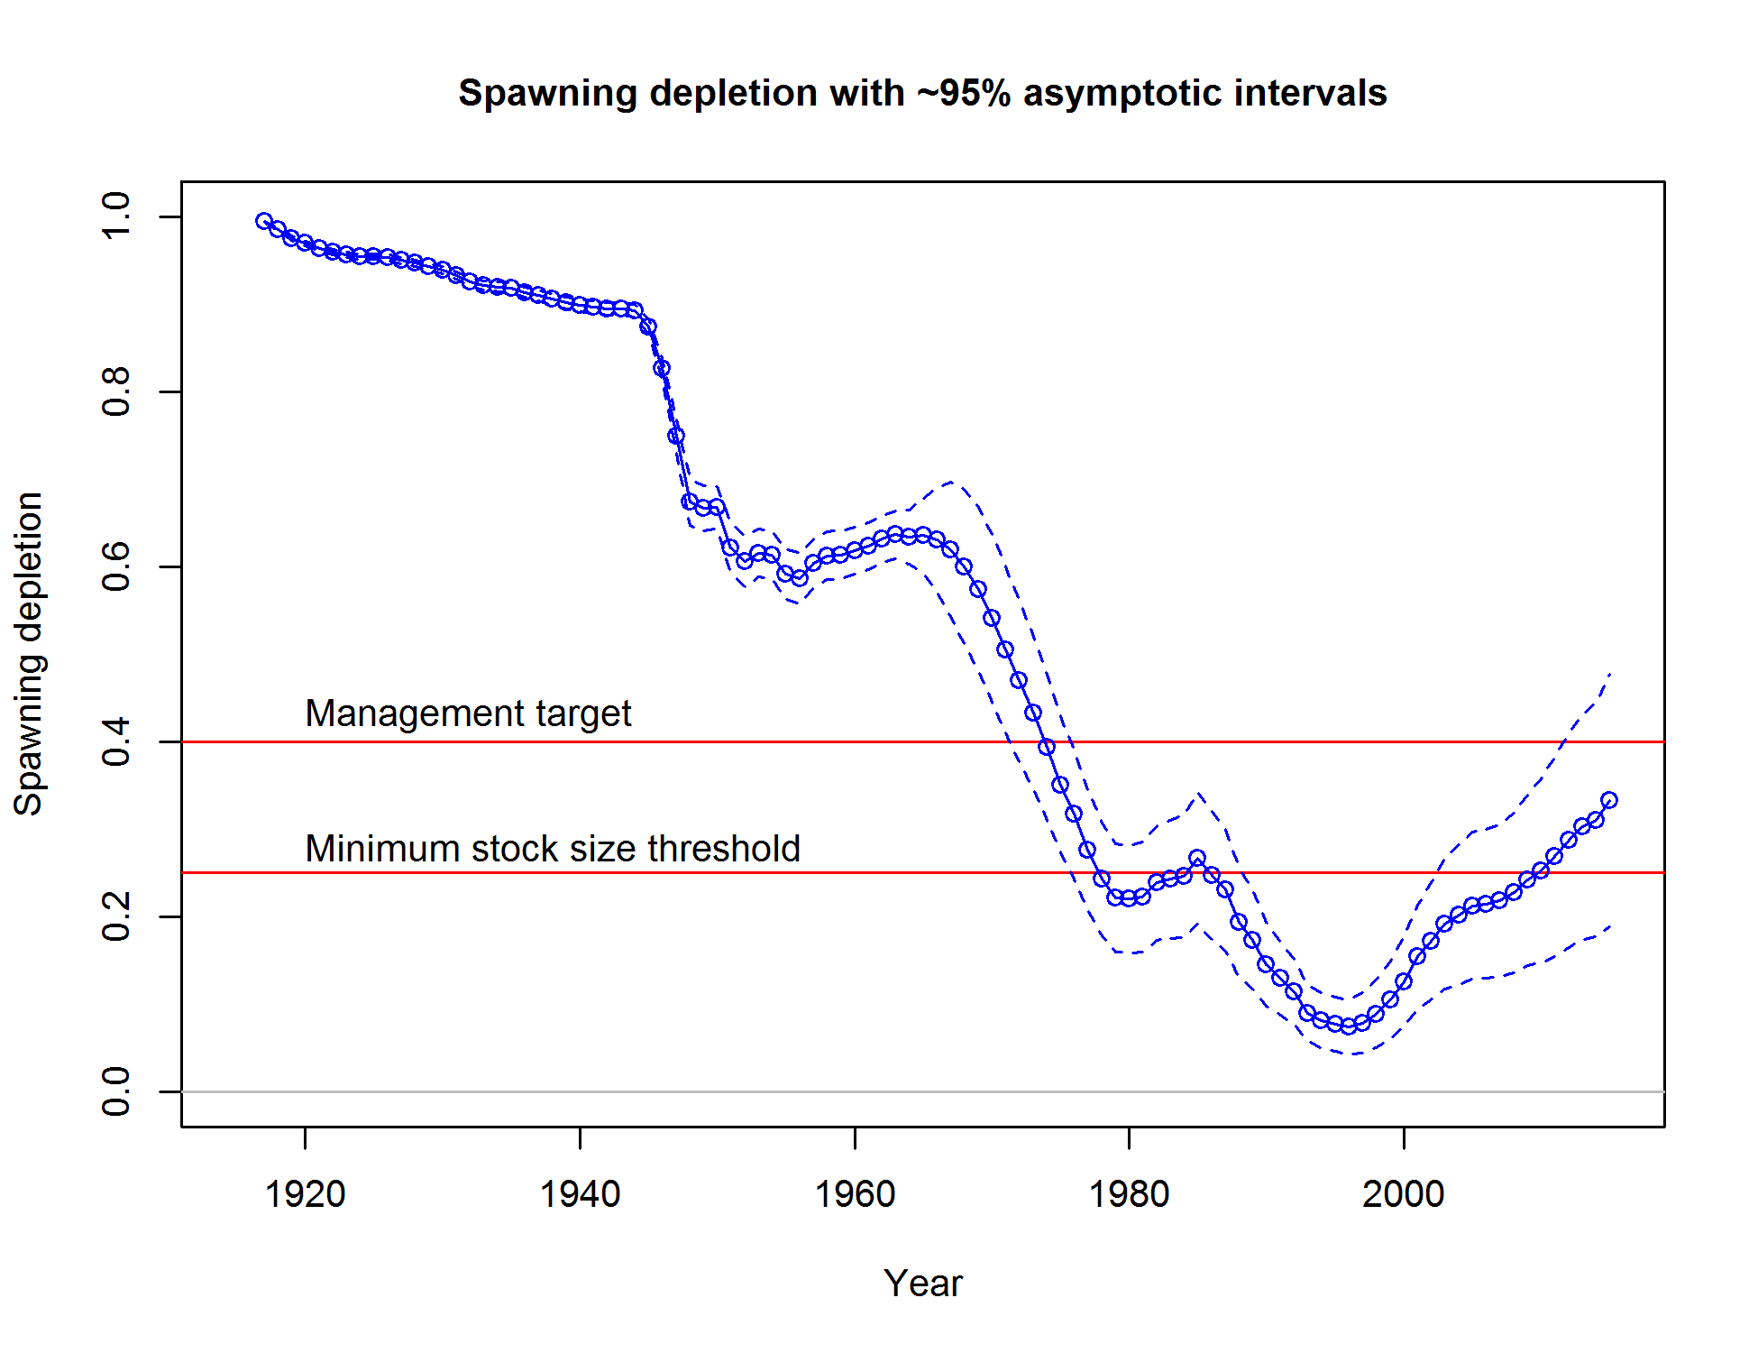

Figure ES-5. Time series of stock status (depletion) of black rockfish in California.

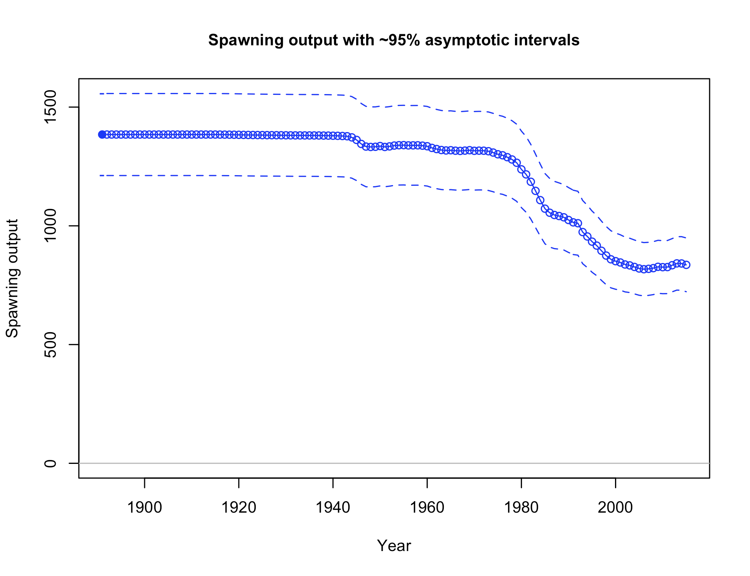

Figure ES-6. Time series of spawning output of black rockfish in Oregon.

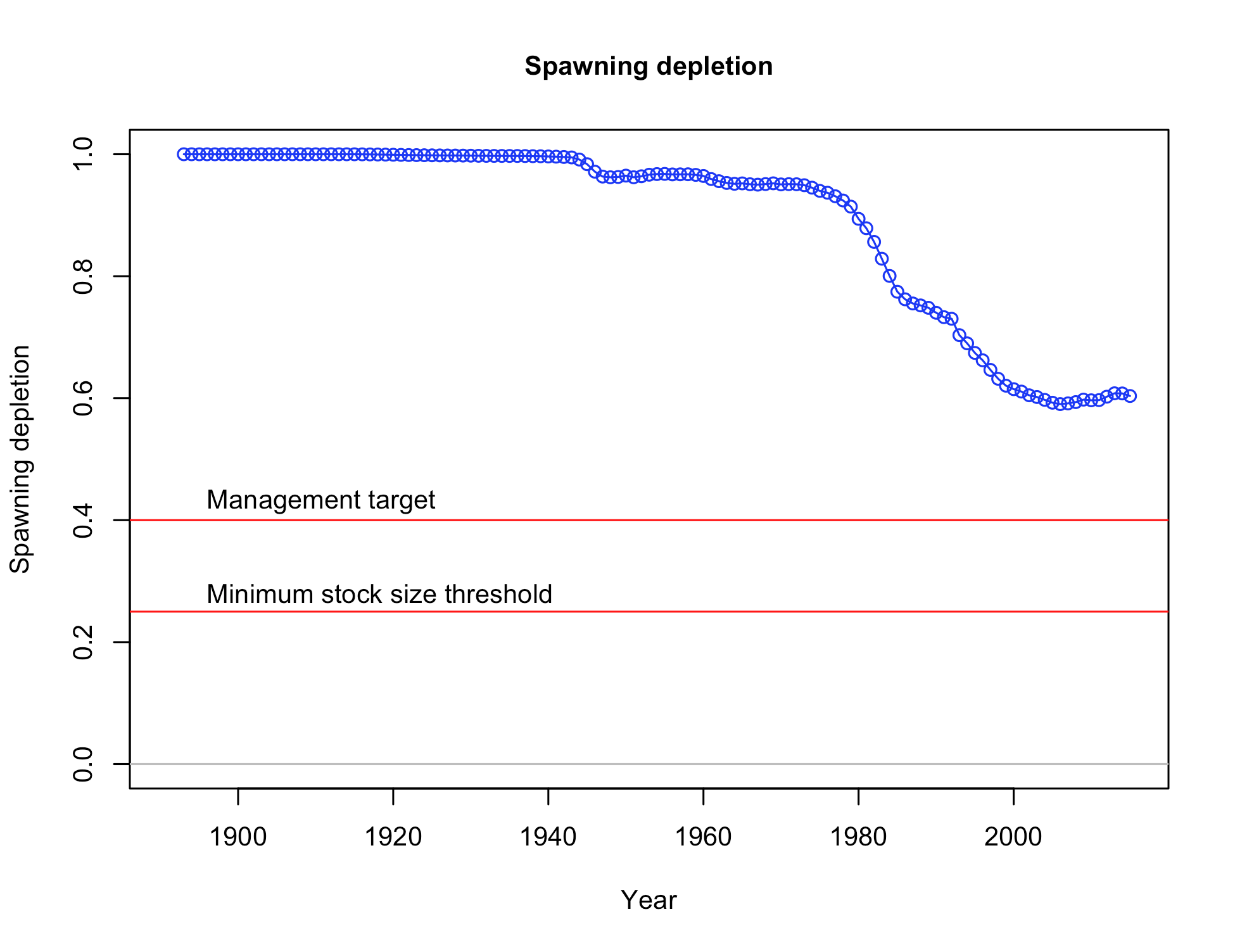

Figure ES-7. Time series of stock status (depletion) of black rockfish in Oregon.

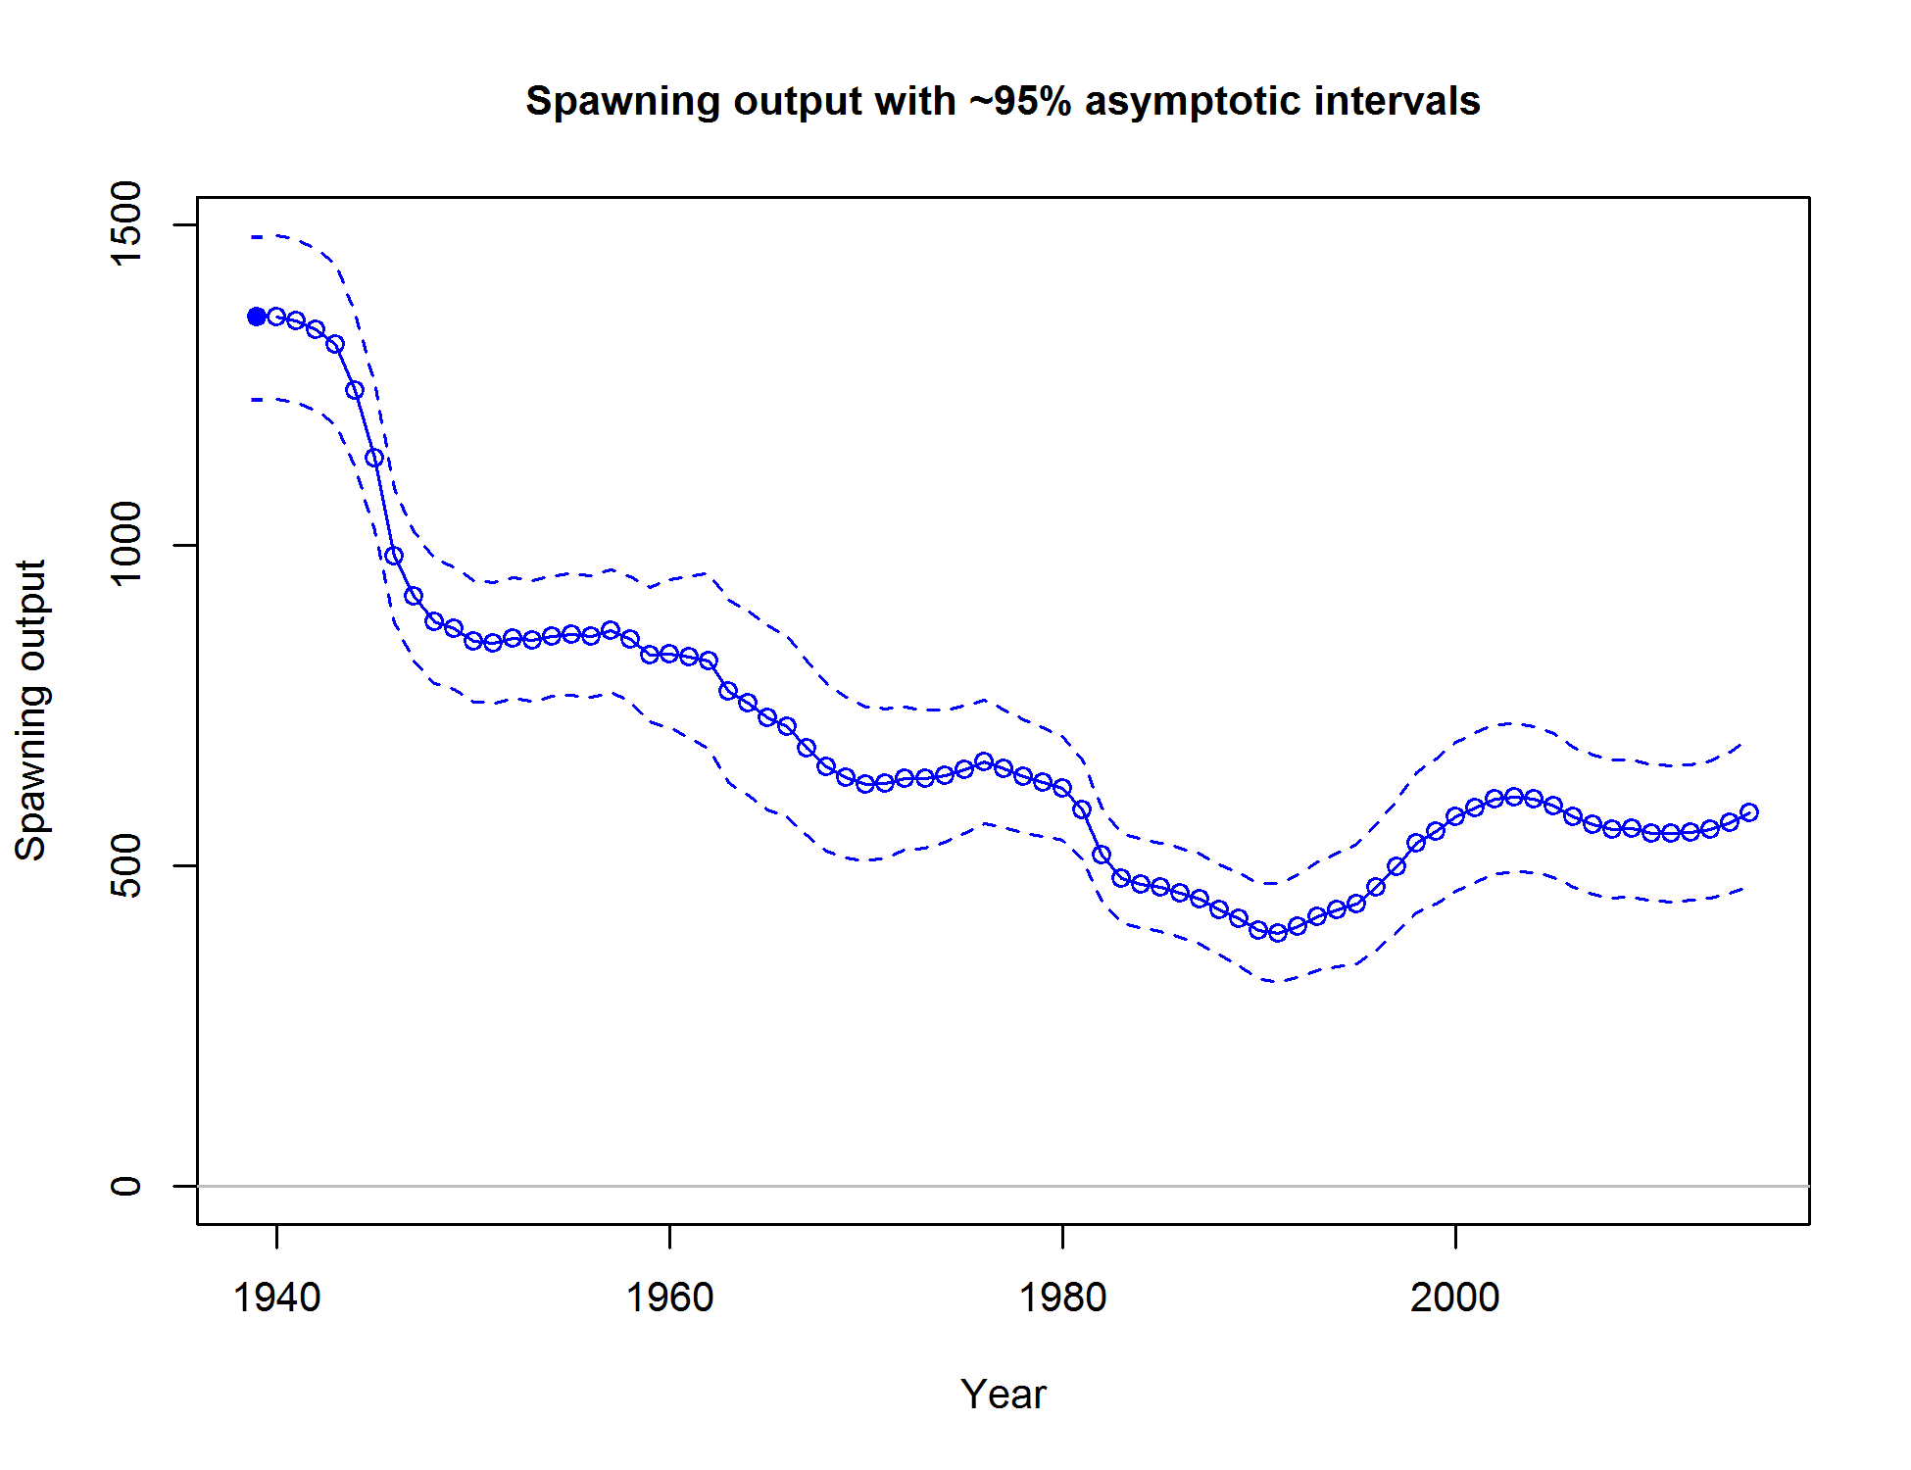

Figure ES-8. Time series of spawning output of black rockfish in Washington.

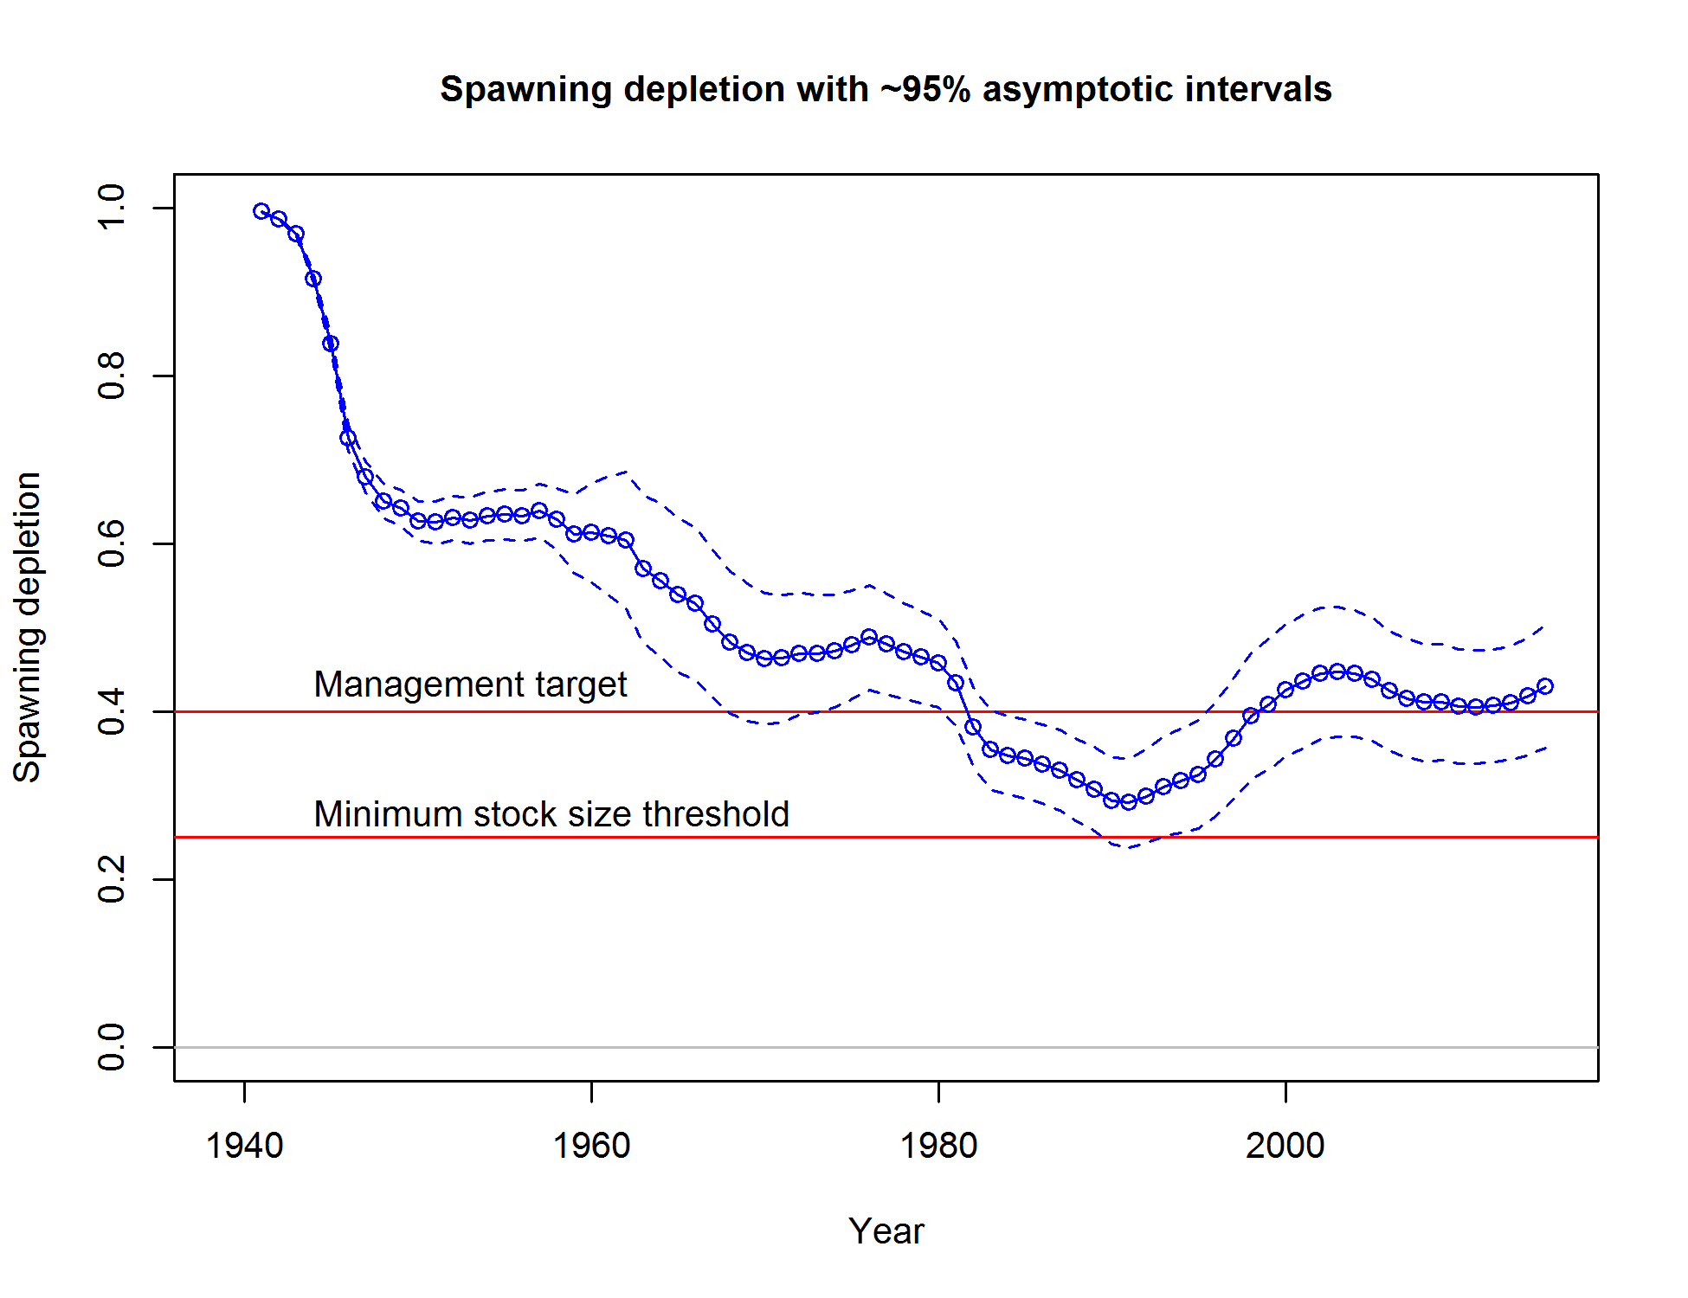

Figure ES-9. Time series of stock status (depletion) of black rockfish in Washington.

Recruitment

The California model shows a few extraordinarily high recruitment events that are supported by the length composition data, index data and on-the-water reports (Table ES-3; Figure ES-10). Oregon recruitment is highly uncertain (Table ES-3; Figure ES11). Washington recruitment is dynamic, but also shows the most informed recruitment time series, which is consistent with the extent of length and age compositions available to that assessment (Table ES-3; Figure ES12). Both California and Washington support elevated recruitment in the late 2000s.

Table ES-3. Recent trend in recruitment for black rockfish by assessment area.

|  |  |  |  |  |  |  |  |  |
| --- | --- | --- | --- | --- | --- | --- | --- | --- |
|  |  |  |  |  |  |  |  |  |
|  | California | |  | Oregon | |  | Washington | |
| Year | Estimated | ~95% |  | Estimated | ~95% |  | Estimated | ~95% |
| recruitment | confidence | recruitment | confidence |  | recruitment | confidence |
| (1,000’s) | interval | (1,000’s) | interval |  | (1,000’s) | interval |
| 2005 | 1371 | 714-2029 |  | 3490 | 3415-3565 |  | 1773 | 1257-2288 |
| 2006 | 984 | 465-1504 |  | 3488 | 3414-3563 |  | 3518 | 2543-4493 |
| 2007 | 1327 | 565-2088 |  | 3489 | 3414-3564 |  | 1739 | 1181-2297 |
| 2008 | 4509 | 2176-6842 |  | 3491 | 3416-3565 |  | 3346 | 2312-4379 |
| 2009 | 4323 | 1560-7086 |  | 3494 | 3419-3568 |  | 518 | 184-852 |
| 2010 | 2997 | 841-5153 |  | 3493 | 3418-3568 |  | 2670 | 1178-4161 |
| 2011 | 1765 | 306-3223 |  | 3493 | 3418-3568 |  | 1157 | 161-2153 |
| 2012 | 1701 | 1206-2195 |  | 3497 | 3422-3571 |  | 1899 | 1396-2402 |
| 2013 | 1719 | 1226-2213 |  | 3501 | 69-6932 |  | 1901 | 1398-2404 |
| 2014 | 1728 | 1233-2223 |  | 3500 | 69-6932 |  | 1907 | 1403-2411 |
|  |  |  |  |  |  |  |  |  |

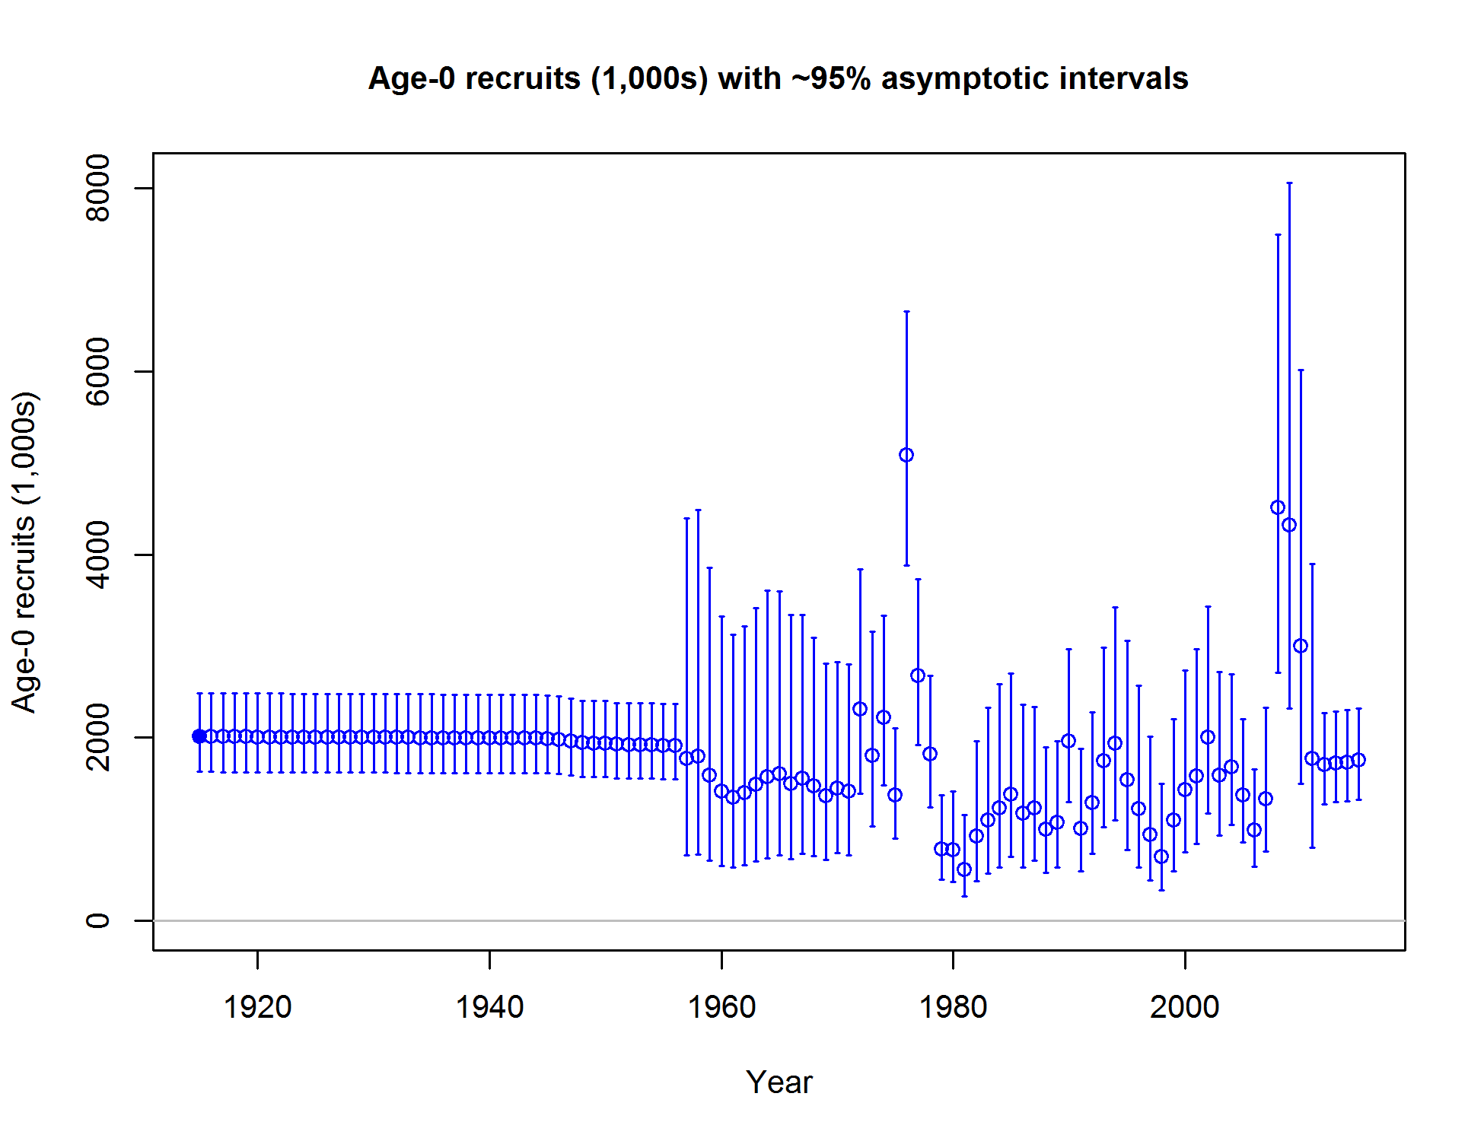

Figure ES-10. Time series of black rockfish recruitment in California.

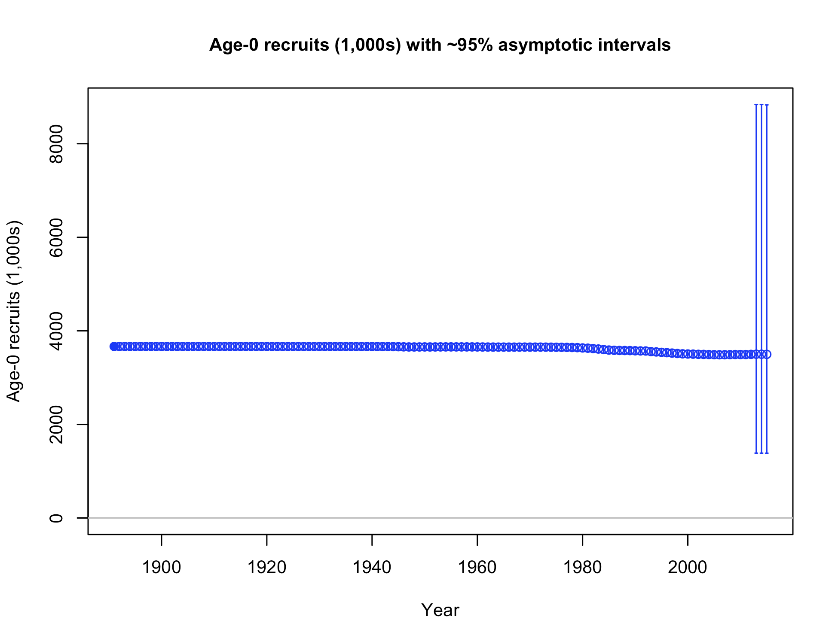

Figure ES-11. Time series of black rockfish recruitment in Oregon. Recruitment deviations were not estimated in the Oregon model.

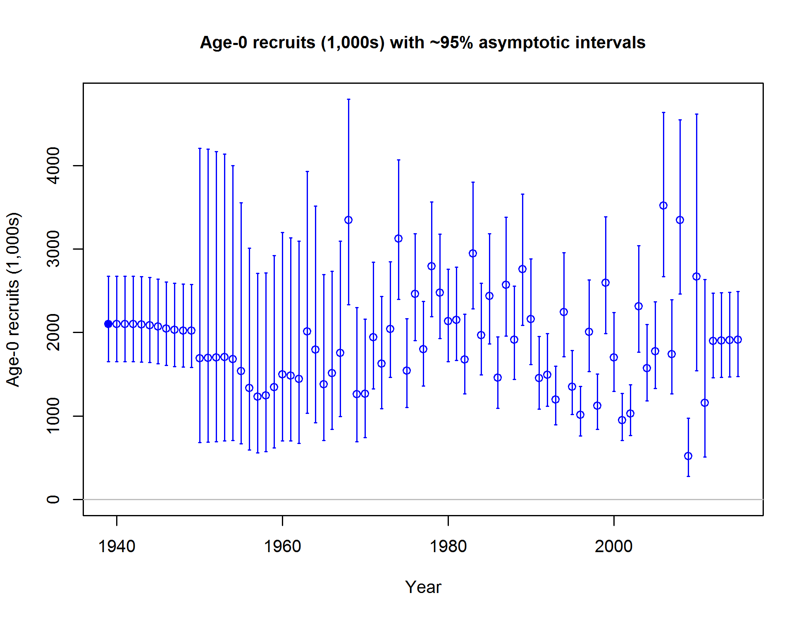

Figure ES-12. Time series of black rockfish recruitment in Washington.

Exploitation status

California and Washington models indicate that current fishing practices are near or above the SPR rate fishing intensity target, while the Oregon model is quite a bit above the target (table ES-4, compare to SPR=0.5; Figure ES-13 to Figure ES-18), though the steepness value (0.773) indicates a much lower value of SPR for sustainable removals. Fishing rates have been above the target in California in nearly all years since the 1980s, but have dropped considerably in recent years. Oregon fishing rates have been consistently high in recent years. Washington shows a dramatic decline in fishing intensity since the late 1990s and has fluctuated mostly below the target since.

Table ES-4. Recent trend in spawning potential ratio (entered as 1-SPR) and summary exploitation rate (catch divided by biomass of age-3 and older fish)

|  |  |  |  |  |  |  |  |  |  |  |  |  |  |  |  |  |  |  |
| --- | --- | --- | --- | --- | --- | --- | --- | --- | --- | --- | --- | --- | --- | --- | --- | --- | --- | --- |
|  | Washington | | | | |  | Oregon | | | | | |  | California | | | | |
| Year |  | ~95% |  |  | ~95% |  |  | ~95% |  |  | | ~95% |  |  | ~95% |  |  | ~95% |
| Estimated 1-SPR | confidence | Harvest rate | confidence |  | Estimated 1-SPR | confidence | Harvest rate | | confidence |  | Estimated 1-SPR | confidence | Harvest rate | confidence |
| interval | (ratio) | interval |  | interval | (ratio) | | interval |  | interval | (ratio) | interval |
| 2005 | 0.60 | 0.48-0.72 |  | 0.09 | 0.06-0.12 |  | 0.38 | 0.37-.040 |  | 0.08 | 0.076-0.084 | |  | 0.54 | 0.47-0.61 |  | 0.08 | 0.07-0.1 |
| 2006 | 0.58 | 0.45-0.7 |  | 0.08 | 0.06-0.11 |  | 0.35 | 0.33-.036 |  | 0.07 | 0.066-0.074 | |  | 0.54 | 0.47-0.61 |  | 0.08 | 0.07-0.1 |
| 2007 | 0.53 | 0.41-0.65 |  | 0.08 | 0.05-0.1 |  | 0.35 | 0.33-.036 |  | 0.07 | 0.066-0.074 | |  | 0.52 | 0.45-0.59 |  | 0.08 | 0.06-0.09 |
| 2008 | 0.53 | 0.41-0.66 |  | 0.08 | 0.05-0.1 |  | 0.33 | 0.32-.034 |  | 0.07 | 0.066-0.074 | |  | 0.45 | 0.38-0.51 |  | 0.06 | 0.05-0.07 |
| 2009 | 0.65 | 0.52-0.78 |  | 0.10 | 0.07-0.14 |  | 0.39 | 0.38-.041 |  | 0.09 | 0.086-0.094 | |  | 0.48 | 0.41-0.55 |  | 0.07 | 0.06-0.08 |
| 2010 | 0.56 | 0.42-0.69 |  | 0.08 | 0.05-0.11 |  | 0.37 | 0.36-.039 |  | 0.08 | 0.076-0.084 | |  | 0.44 | 0.37-0.51 |  | 0.06 | 0.05-0.07 |
| 2011 | 0.46 | 0.33-0.59 |  | 0.06 | 0.04-0.08 |  | 0.30 | 0.29-.031 |  | 0.06 | 0.058-0.062 | |  | 0.45 | 0.38-0.51 |  | 0.06 | 0.05-0.07 |
| 2012 | 0.45 | 0.32-0.57 |  | 0.05 | 0.03-0.07 |  | 0.31 | 0.29-.032 |  | 0.06 | 0.056-0.064 | |  | 0.49 | 0.42-0.56 |  | 0.07 | 0.06-0.08 |
| 2013 | 0.57 | 0.44-0.7 |  | 0.08 | 0.05-0.11 |  | 0.38 | 0.37-.039 |  | 0.08 | 0.076-0.084 | |  | 0.52 | 0.45-0.59 |  | 0.08 | 0.06-0.09 |
| 2014 | 0.53 | 0.4-0.67 |  | 0.07 | 0.05-0.1 |  | 0.41 | 0.40-0.43 |  | 0.09 | 0.086-0.094 | |  | 0.54 | 0.47-0.61 |  | 0.08 | 0.07-0.1 |

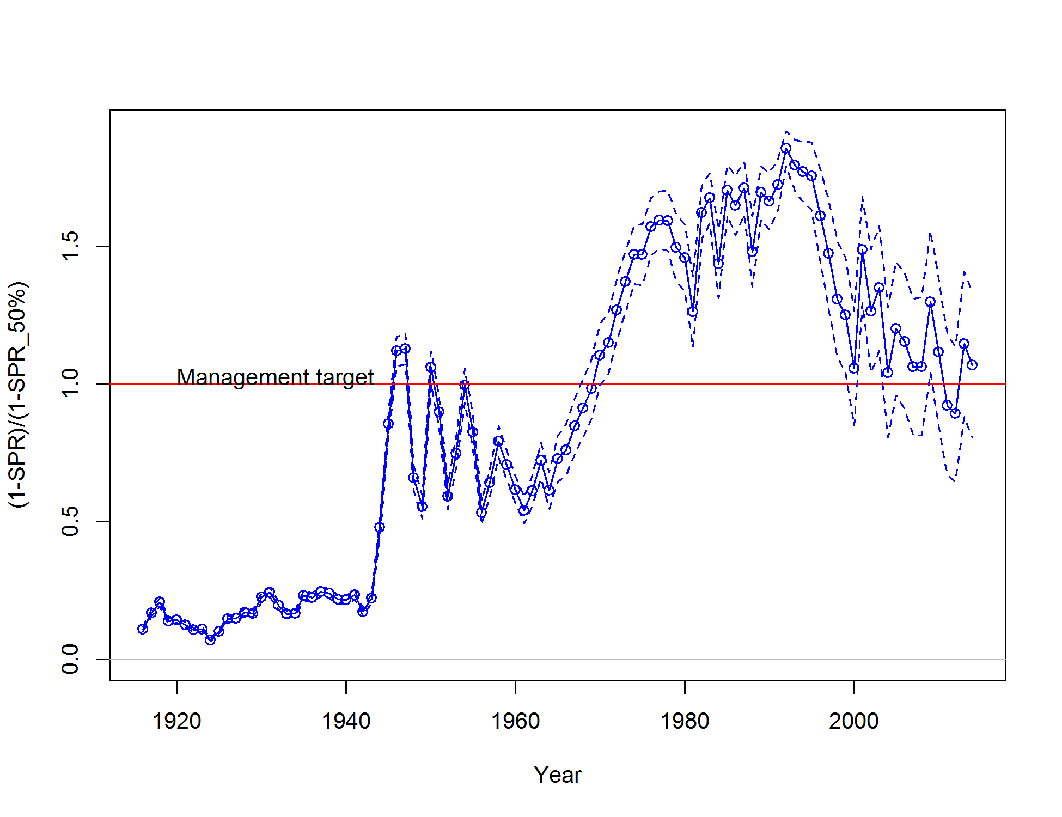

Figure ES-13. Estimated spawning potential ratio (SPR) for the California assessment. Relative SPR is plotted so that higher exploitation rates occur on the upper portion of the y-axis. The management target is plotted as a red horizontal line and values above this reflect harvests in excess of the overfishing proxy based on the SPR50% harvest rate. The last year in the time series is 2014.

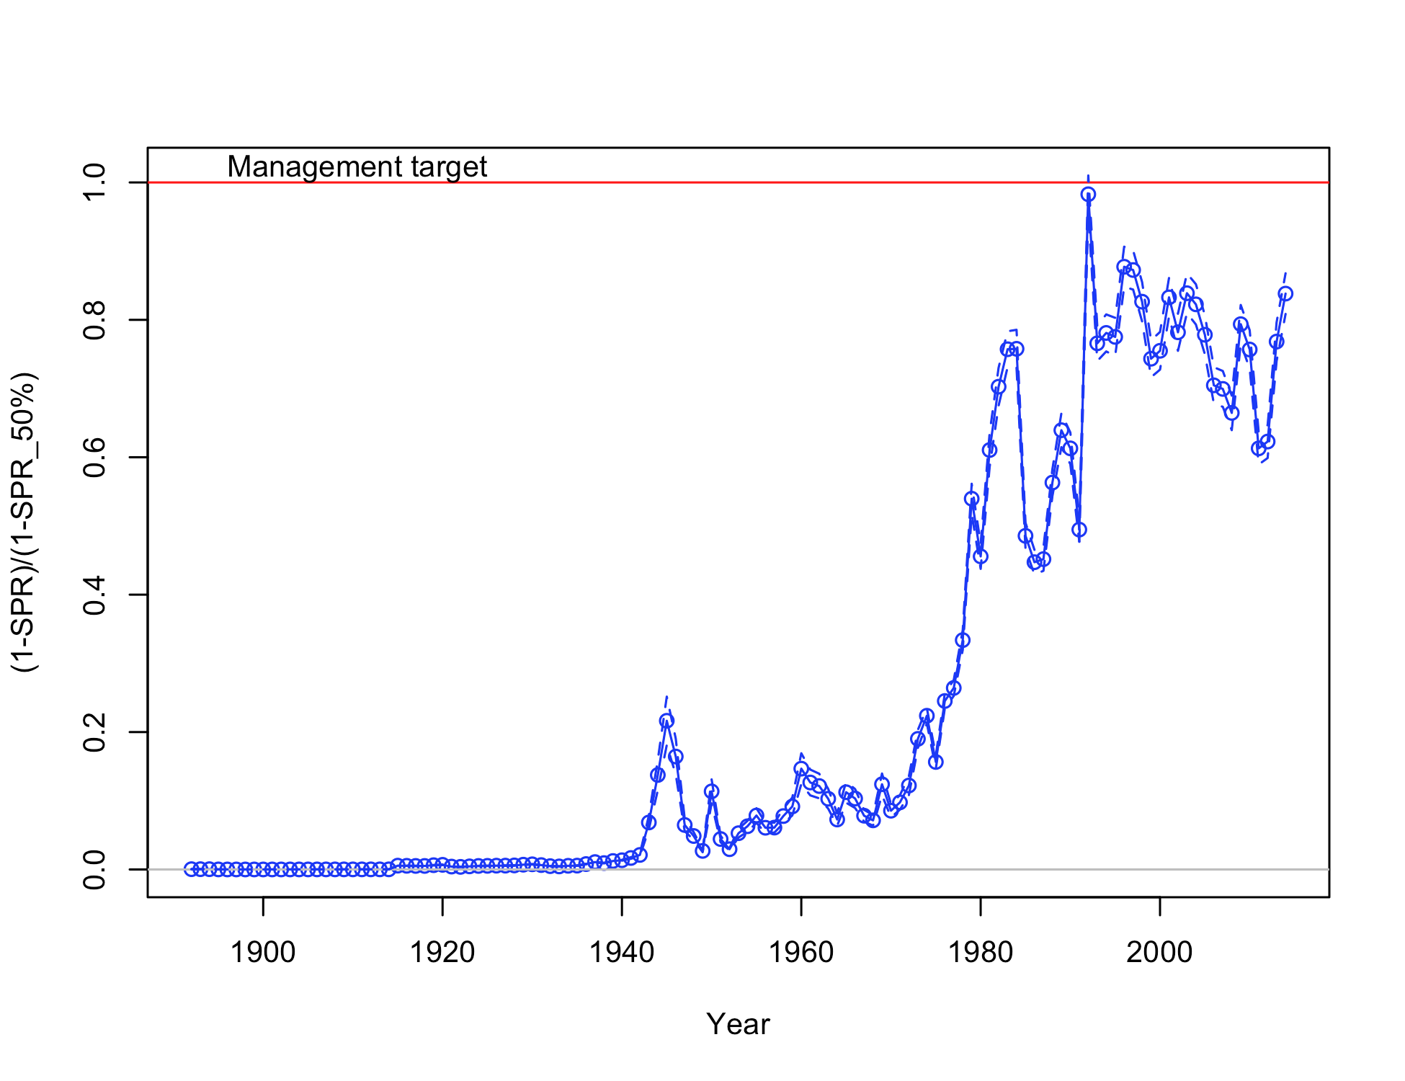

Figure ES-14. Estimated spawning potential ratio (SPR) for the Oregon assessment. Relative SPR is plotted so that higher exploitation rates occur on the upper portion of the y-axis. The management target is plotted as a red horizontal line and values above this reflect harvests in excess of the overfishing proxy based on the SPR50% harvest rate. The last year in the time series is 2014.

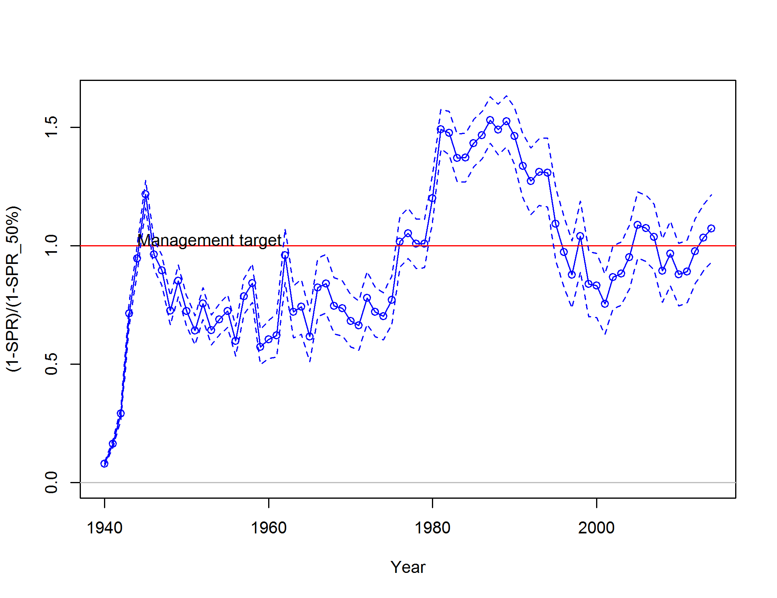

Figure ES-15. Estimated spawning potential ratio (SPR) for the Washington assessment. Relative SPR is plotted so that higher exploitation rates occur on the upper portion of the y-axis. The management target is plotted as a red horizontal line and values above this reflect harvests in excess of the overfishing proxy based on the SPR50% harvest rate. The last year in the time series is 2014.

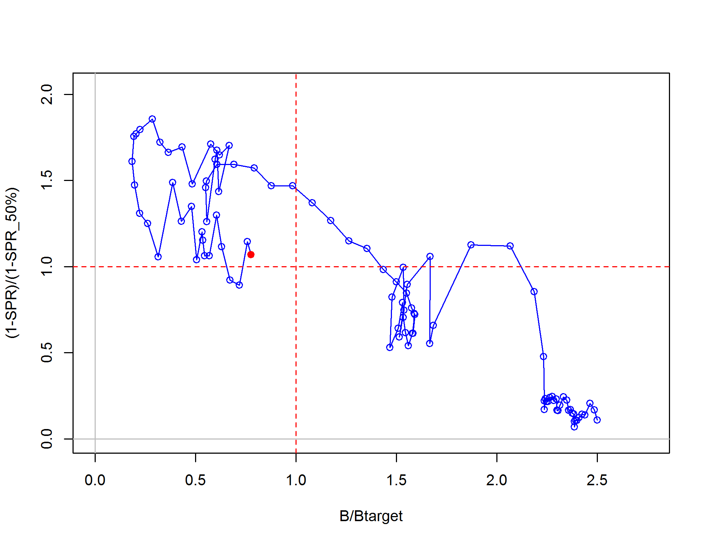

Figure ES-16. Phase plot of relative spawning biomass vs fishing intensity for the California model. The relative fishing intensity is (1-SPR) divided by 1-the SPR target. The vertical red line is the relative spawning biomass target defined as the annual spawning output divided by the spawning biomass corresponding to 40% of the unfished spawning biomass.

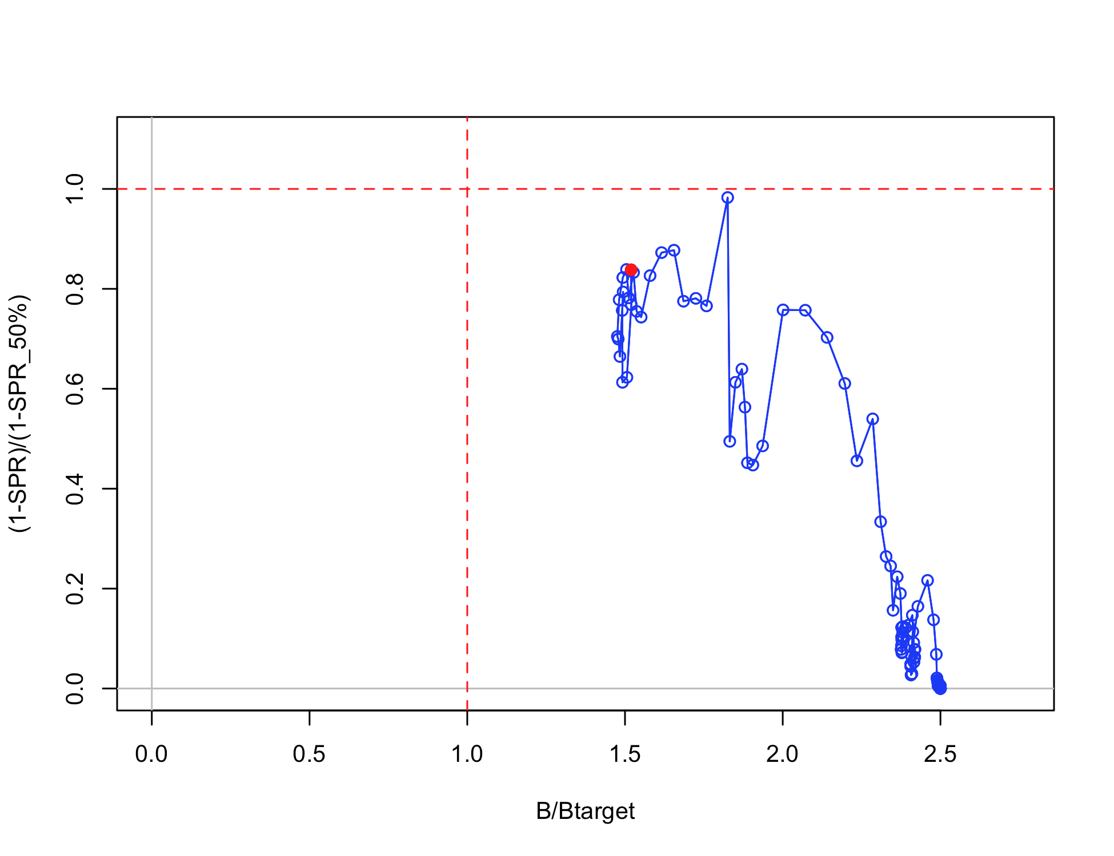

Figure ES-17. Phase plot of relative spawning biomass vs fishing intensity for the Oregon model. The relative fishing intensity is (1-SPR) divided by 1-the SPR target. The vertical red line is the relative spawning biomass target defined as the annual spawning biomass divided by the spawning output corresponding to 40% of the unfished spawning biomass.

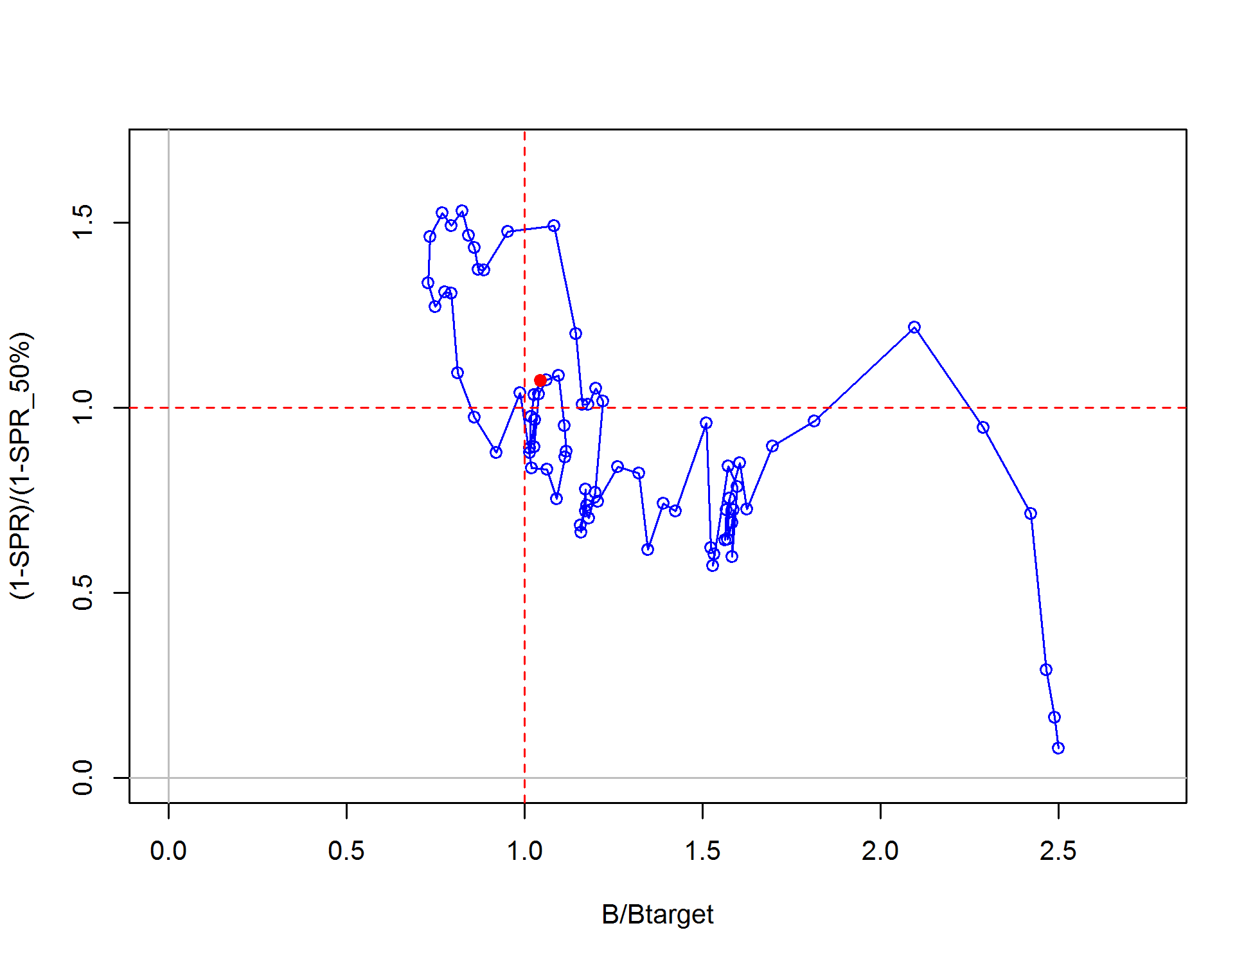

Figure ES-18. Phase plot of relative spawning biomass vs fishing intensity for the Washington model. The relative fishing intensity is (1-SPR) divided by 1-the SPR target. The vertical red line is the relative spawning biomass target defined as the annual spawning output divided by the spawning biomass corresponding to 40% of the unfished spawning biomass.

Ecosystem considerations

Ecosystem considerations were not explicitly included in these models, though growth deviations were considered in the Washington model. While no mechanisms have been put forth for these time-varying changes in growth, an environmental component is possible. Limited data in Oregon and California also suggest the possibility that growth has changed over time.

Reference points

Reference points were based on the rockfish FMSY proxy (SPR50%), target relative biomass (40%) and model-estimated selectivity for each fleet. California is below the target biomass reference point, but above the limit reference biomass (25%). Oregon is well above the target biomass. Washington relative biomass is above the target biomass. California and Washington yield values are lower than the previous assessment for similar reference points due to lower overall natural mortality values (Table ES-5). The proxy MSY values of management quantities are the most conservative compared to the estimated MSY and MSY relative to 40% biomass for both California and Washington (Table ES-5). The equilibrium estimates of yield relative to biomass are provided in Figure ES-19 to Figure ES-21.

Table ES-5. Summary of reference points for each black rockfish base case model.

California

|  |  |  |
| --- | --- | --- |
| **Quantity** | **Estimate** | **~95% Confidence Interval** |
|
| Unfished Spawning output (mt) | 1062 | 830-1293 |
| Unfished age 3+ biomass (mt) | 9540 | 8862-10219 |
| Unfished recruitment (R0) | 2010 | 1580-2440 |
| Depletion (2015) | 0.33 | 0.19-0.48 |
| ***Reference points based on SB40%*** |  |  |
| Proxy spawning output (*B40%*) | 425 | 332-517 |
| SPR resulting in *B40%* (*SPR50%*) | 0.444 | 0.44-0.44 |
| Exploitation rate resulting in *B40%* | 0.075 | 0-0.0811 |
| Yield with *SPR50%* at *B40%* (mt) | 343 | 316-369 |
| ***Reference points based on SPR proxy for MSY*** |  |  |
| Spawning output | 489 | 382-595 |
| *SPRproxy* | 0.5 |  |
| Exploitation rate corresponding to *SPRproxy* | 0.064 | 0.06-0.07 |
| Yield with *SPRproxy* at *SBSPR* (mt) | 319 | 295-344 |
| ***Reference points based on estimated MSY values*** |  |  |
| Spawning output at *MSY* (*SBMSY*) | 254 | 199-309 |
| *SPRMSY* | 0.295 | 0.29-0.3 |
| Exploitation rate corresponding to *SPRMSY* | 0.117 | 0.11-0.13 |
| *MSY* (mt) | 376 | 345-408 |

Oregon

|  |  |  |
| --- | --- | --- |
| **Quantity** | **Estimate** | **~95% Confidence Interval** |
|
| Unfished Spawning biomass (mt) | 1385 | 1212-1557 |
| Unfished age 3+ biomass (mt) | 11611 | 11318-11905 |
| Unfished recruitment (R0) | 3666 | 3594-3738 |
| Depletion (2015) | 60.4 | 58.9-61.8 |
| ***Reference points based on SB40%*** |  |  |
| Proxy spawning biomass (*B40%*) | 554 | 485-623 |
| SPR resulting in *B40%* (*SPR50%*) | 0.444 |  |
| Exploitation rate resulting in *B40%* | 0.116 | 0.108-0.125 |
| Yield with *SPR50%* at *B40%* (mt) | 518 | 503-532 |
| ***Reference points based on SPR proxy for MSY*** |  |  |
| Spawning biomass | 637 | 558-717 |
| *SPRproxy* | 0.5 |  |
| Exploitation rate corresponding to *SPRproxy* | 0.116 | 0.108-0.125 |
| Yield with *SPRproxy* at *SBSPR* (mt) | 518 | 503-532 |
| ***Reference points based on estimated MSY values*** |  |  |
| Spawning biomass at *MSY* (*SBMSY*) | 318 | 276-360 |
| *SPRMSY* | 0.286 | 0.283-0.289 |
| Exploitation rate corresponding to *SPRMSY* | 0.209 | 0.197-0.221 |
| *MSY* (mt) | 616 | 602-630 |

Washington

|  |  |  |
| --- | --- | --- |
| **Quantity** | **Estimate** | **~95% Confidence Interval** |
|
| Unfished Spawning output (mt) | 1356 | 1228-1483 |
| Unfished age 3+ biomass (mt) | 9119 | 8467-9772 |
| Unfished recruitment (R0) | 2102 | 1593-2610 |
| Depletion (2015) | 0.43 | 0.36-0.5 |
| ***Reference points based on SB40%*** |  |  |
| Proxy spawning output (*B40%*) | 542 | 491-593 |
| SPR resulting in *B40%* (*SPR50%*) | 0.444 | 0.44-0.44 |
| Exploitation rate resulting in *B40%* | 0.086 | 0.08-0.09 |
| Yield with *SPR50%* at *B40%* (mt) | 337 | 298-376 |
| ***Reference points based on SPR proxy for MSY*** |  |  |
| Spawning output | 624 | 565-683 |
| *SPRproxy* |  |  |
| Exploitation rate corresponding to *SPRproxy* | 0.072 | 0.07-0.08 |
| Yield with *SPRproxy* at *SBSPR* (mt) | 311 | 275-346 |
| ***Reference points based on estimated MSY values*** |  |  |
| Spawning output at *MSY* (*SBMSY*) | 294 | 267-322 |
| *SPRMSY* | 0.274385 | 0.27-0.28 |
| Exploitation rate corresponding to *SPRMSY* | 0.149 | 0.14-0.16 |
| *MSY* (mt) | 383 | 337-430 |

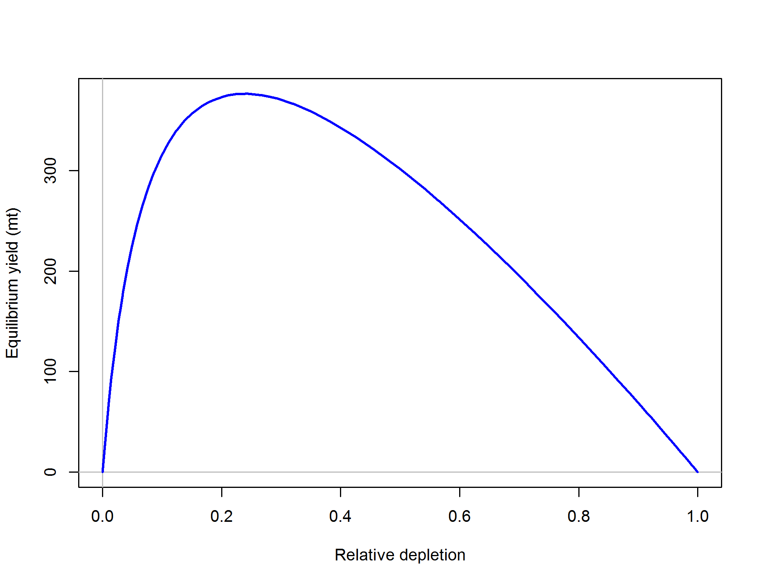

Figure ES-19. Equilibrium yield curve (derived from reference point values reported in Table ES-5) for the California base case model. Values are based on 2014 fishery selectivity and distribution with steepness fixed at 0.773. The depletion is relative to unfished spawning biomass.

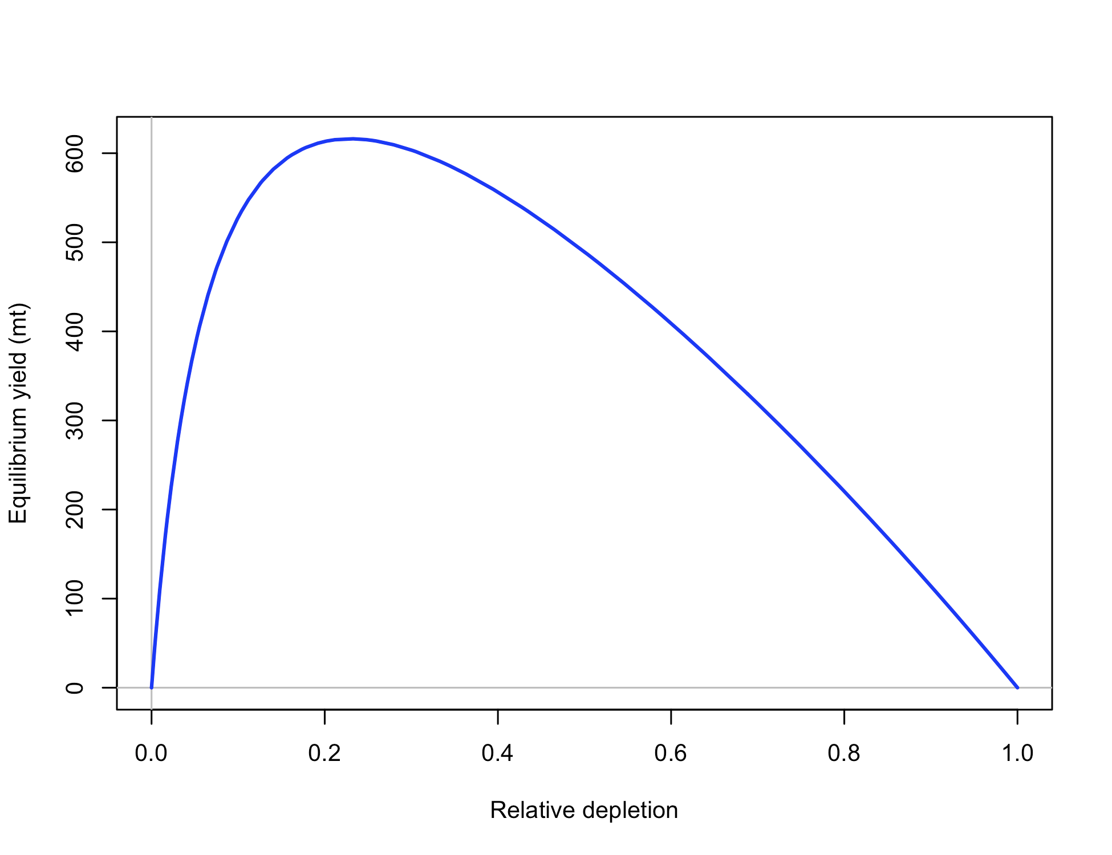

Figure ES-20. Equilibrium yield curve (derived from reference point values reported in Table ES-5) for the Oregon base case model. Values are based on 2014 fishery selectivity and distribution with steepness fixed at 0.773. The depletion is relative to unfished spawning biomass.

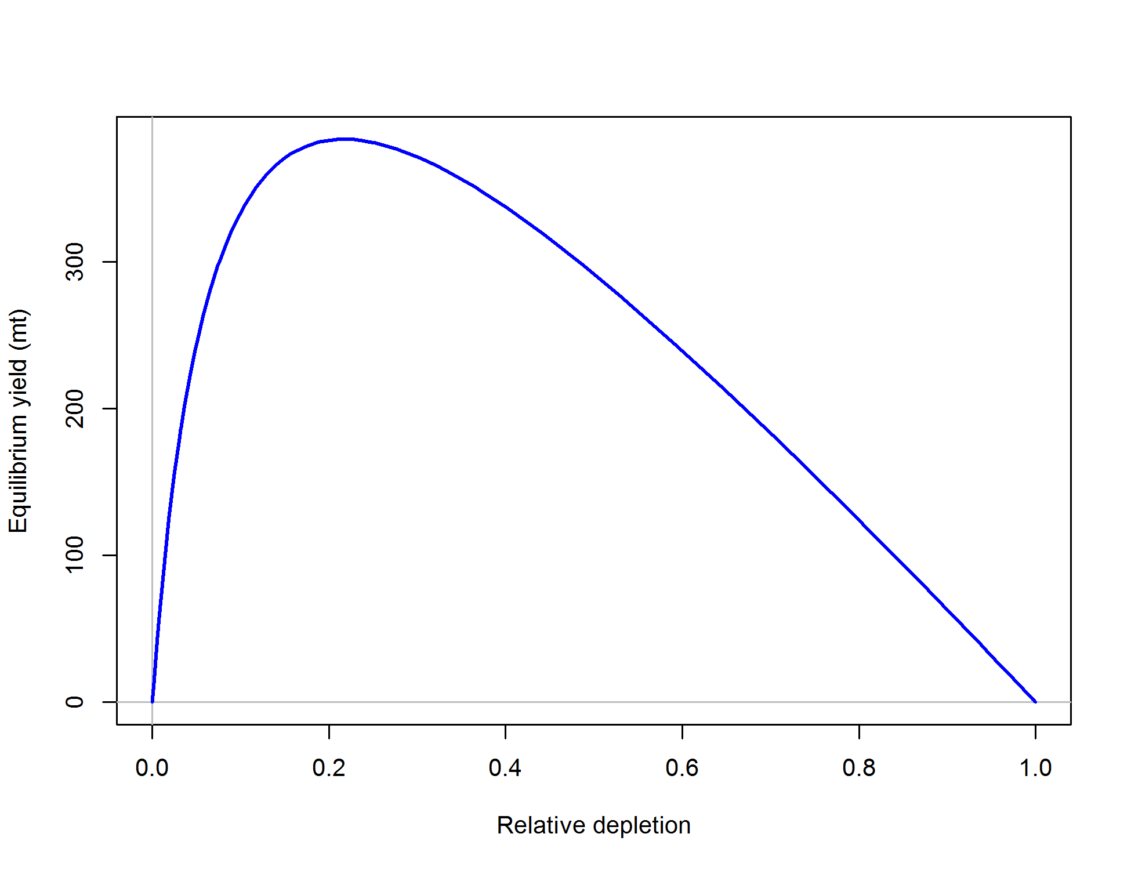

Figure ES-21. Equilibrium yield curve (derived from reference point values reported in Table ES-5) for the Washington base case model. Values are based on 2014 fishery selectivity and distribution with steepness fixed at 0.773. The depletion is relative to unfished spawning biomass.

Management performance

Removals have been below the equivalent ABC-ACL since the prior assessment (Table ES-6), but those specified ABCs from the 2007 assessments are higher than those coming from the current assessment models. Removals over the last few years have or may have exceeded the newly estimated ABC-ACL values in some years. The differences in the treatment of natural mortality between the previous and current assessments are the biggest reason for this discrepancy.

Table ES-6. Recent trend in total catch and commercial landings (mt) relative to the management guidelines.  Estimated total catch reflect the commercial landings plus estimated discarded biomass.

|  |  |  |  |  |  |  |  |  |
| --- | --- | --- | --- | --- | --- | --- | --- | --- |
|  |  |  |  |  |  |  |  |  |
|  | OFL (mt) | |  | ABC/ACL (mt) | |  | Removals (mt) | |
| Year | CA + OR | WA |  | CA + OR | WA |  | CA + OR | WA |
| 2007 | 722 | 540 |  | 722 | 540 |  | 577 | 287 |
| 2008 | 722 | 540 |  | 722 | 540 |  | 593 | 222 |
| 2009 | 1469 | 490 |  | 1000 | 490 |  | 784 | 251 |
| 2010 | 1317 | 464 |  | 1000 | 464 |  | 650 | 219 |
| 2011 | 1163 | 426 |  | 1000 | 426 |  | 523 | 232 |
| 2012 | 1117 | 415 |  | 1000 | 415 |  | 563 | 282 |
| 2013 | 1108 | 411 |  | 1000 | 411 |  | 845 | 325 |
| 2014 | 1115 | 409 |  | 1000 | 409 |  | 865 | 356 |

Unresolved problems and major uncertainties

The most significant uncertainty for all models is the treatment and value of natural mortality and the form of fleet selectivity (e.g., length-based asymptotic vs. age-based dome-shaped selectivity). Data-driven selection between the extreme “kill” (using a ramping of M) or “hide” hypotheses are not currently resolvable. The current California and Washington base models instead use a form of the “kill” hypothesis by not implementing the age-based selectivity (“hide” hypothesis) and estimating female and male natural mortality, thus avoiding a fixing natural mortality as was necessary in the Oregon model. The Oregon model also contained a step in female natural mortality, a specification not used in the California or Washington models. Another important issue is the highly uncertain historical time-series of removals in all states, which needs further consideration. The development of fishery-dependent indices of abundance still requires further attention. Steepness, while fixed, is still highly uncertain for rockfishes and currently is mismatched to the MSY proxy. And while the steepness profile shows low sensitivity in several derived quantities, steepness strongly defines the yield capacity of stocks, and therefore could cause major uncertainty in the recommended management quantities. Stock structure and its relationship to the current political/management boundaries are also not fully understood, both within U.S. jurisdiction and between the U.S. and Canada. While this is a common challenge faced in most west coast stock assessments, further improvement on this topic will likely rely on black rockfish-specific data.

Harvest projections and decision tables

Black rockfish assessments for California and Washington have a preliminary distinction as category 1 stock assessments, thus harvest projections and decision tables are based on using P*=0.45 and sigma = 0.36, resulting in a multiplier on the OFL of 0.956. The Oregon black rockfish assessment is a category 2 assessment, with a P*=0.45 and sigma = 0.72 with a multiplier of 0.913 applied to the OFL. These multipliers are also combined with the rockfish MSY proxy of FSPR=50% MSY and the 40-10 harvest control rule to calculate OFLs, ABCs and ACLs. Projections for each state are provided in Table ES-7 to Table ES-9.

Uncertainty in management quantities for the base model of each state was characterized by exploring various model specifications in a decision table. Initial exploration included natural mortality and steepness values, and uncertainty in historical trawl catches for the WA and CA models. OR explored the scale factor coming from the value of the tagging catchability (Q) parameter, as well as M values. For the CA and WA models, there was very little sensitivity to steepness and trawl catches, but natural mortality produced sensitive results of predicted population scale and status. Discussion with the STAR panel resulted in high and low states of nature +/- 0.03 from the base case natural mortality values for females and males. High and low catch streams (rows) were determined by the forecasts, as described above, for each state of nature. Thus the low catch stream is based on the forecast from the low state of nature. The OR model demonstrated little sensitivity to *M*, but high sensitivity to the tagging survey Q. High and low states of nature, respectively, were based on a fixed tag of Q = 0.125 and Q estimated by the model. Resultant decision tables are provided in Table ES-10 to Table ES-12.

Table ES-7. Harvest projection of potential OFL and prescribed removals, summary biomass (age-3 and older), spawning output, and depletion for the California base case model projected with total projected catch equal to the 420 mt for 2015 and 2016. The predicted OFL is the calculated total catch determined by FSPR=50%.

|  |  |  |  |  |  |
| --- | --- | --- | --- | --- | --- |
|  | Predicted OFL | Projected removals | Age 3+ biomass | Spawning output | Depletion (%) |
| Year |
| 2015 | 354 | 420 | 5,773 | 353 | 33% |
| 2016 | 354 | 420 | 5,800 | 396 | 37% |
| 2017 | 349 | 334 | 5,754 | 450 | 42% |
| 2018 | 347 | 332 | 5,747 | 503 | 47% |
| 2019 | 344 | 329 | 5,716 | 538 | 51% |
| 2020 | 341 | 326 | 5,677 | 555 | 52% |
| 2021 | 338 | 323 | 5,640 | 558 | 53% |
| 2022 | 336 | 321 | 5,608 | 554 | 52% |
| 2023 | 334 | 319 | 5,583 | 547 | 52% |
| 2024 | 333 | 318 | 5,565 | 539 | 51% |
| 2025 | 332 | 318 | 5,550 | 532 | 50% |
| 2026 | 332 | 317 | 5,540 | 526 | 50% |

Table ES-8. Harvest projection of potential OFL and prescribed removals, summary biomass (age-3 and older), spawning output, and depletion for the Oregon base case model projected with total projected catch equal to the 580 mt for 2015 and 2016. The predicted OFL is the calculated total catch determined by FSPR=50%.

|  |  |  |  |  |  |
| --- | --- | --- | --- | --- | --- |
|  | Predicted OFL | Projected removals | Age 3+ biomass | Spawning output | Depletion (%) |
| Year |
| 2015 | 606 | 580 | 7819 | 795 | 60% |
| 2016 | 590 | 580 | 7665 | 780 | 59% |
| 2017 | 577 | 526 | 7577 | 763 | 58% |
| 2018 | 570 | 520 | 7506 | 749 | 57% |
| 2019 | 565 | 515 | 7449 | 736 | 56% |
| 2020 | 561 | 512 | 7401 | 724 | 55% |
| 2021 | 558 | 510 | 7361 | 715 | 54% |
| 2022 | 556 | 508 | 7326 | 707 | 54% |
| 2023 | 554 | 506 | 7296 | 700 | 53% |
| 2024 | 553 | 504 | 7269 | 694 | 53% |
| 2025 | 551 | 503 | 7245 | 689 | 52% |
| 2026 | 550 | 502 | 7819 | 685 | 52% |

Table ES-9. Harvest projection of potential OFL and prescribed removals, summary biomass (age-3 and older), spawning output, and depletion for the Washington base case model projected with total projected catch equal to the 283 mt for 2015 and 2016. The predicted OFL is the calculated total catch determined by FSPR=50%.

|  |  |  |  |  |  |
| --- | --- | --- | --- | --- | --- |
|  | Predicted OFL | Projected removals | Age 3+ biomass | Spawning output | Depletion (%) |
| Year |
| 2015 | 319 | 283 | 5,645 | 582 | 43% |
| 2016 | 320 | 283 | 5,652 | 610 | 45% |
| 2017 | 319 | 305 | 5,651 | 632 | 47% |
| 2018 | 315 | 301 | 5,629 | 643 | 47% |
| 2019 | 312 | 299 | 5,615 | 646 | 48% |
| 2020 | 311 | 297 | 5,609 | 644 | 48% |
| 2021 | 311 | 297 | 5,610 | 640 | 47% |
| 2022 | 311 | 297 | 5,616 | 636 | 47% |
| 2023 | 311 | 297 | 5,625 | 634 | 47% |
| 2024 | 312 | 298 | 5,635 | 632 | 47% |
| 2025 | 312 | 299 | 5,645 | 632 | 47% |
| 2026 | 313 | 299 | 5,655 | 632 | 47% |

Table ES-10. Summary decision table of 12-year projections for the California model beginning in 2017 for alternate states of nature based on natural mortality. Columns range over low, mid, and high state of nature, and rows range over different assumptions of total catch levels corresponding to the forecast catches from each state of nature. Catches in 2015 and 2016 are allocated to each fleet based on the percentage of landings for each fleet in 2014.

|  |  |  |  |  |  |  |  |  |
| --- | --- | --- | --- | --- | --- | --- | --- | --- |
| California | | | **State of nature** | | | | | |
| Low | | Base case | | High | |
| *Mfemale* = 0.15 ; *Mmale* = 0.10 | | *Mfemale* = 0.18; *Mmale* = 0.13 | | *Mfemale* = 0.21 ; *Mmale* = 0.16 | |
| **Relative probability of states of nature** | | | 0.25 | | 0.5 | | 0.25 | |
| **Management decision** | Year | Catch (mt) | Spawning output | Stock status | Spawning output | Stock status | Spawning output | Stock status |
| Low catch | 2017 | 185 | 325 | 27% | 450 | 42% | 589 | 62% |
| 2018 | 207 | 378 | 31% | 517 | 49% | 668 | 70% |
| 2019 | 222 | 418 | 34% | 567 | 53% | 721 | 76% |
| 2020 | 232 | 446 | 37% | 598 | 56% | 748 | 79% |
| 2021 | 240 | 463 | 38% | 613 | 58% | 754 | 79% |
| 2022 | 246 | 474 | 39% | 620 | 58% | 748 | 79% |
| 2023 | 251 | 482 | 40% | 621 | 59% | 736 | 77% |
| 2024 | 255 | 488 | 40% | 620 | 58% | 722 | 76% |
| 2025 | 259 | 493 | 41% | 617 | 58% | 707 | 74% |
| 2026 | 262 | 498 | 41% | 615 | 58% | 694 | 73% |
| Base catch | 2017 | 334 | 325 | 27% | 450 | 42% | 589 | 62% |
| 2018 | 332 | 364 | 30% | 503 | 47% | 654 | 69% |
| 2019 | 329 | 389 | 32% | 538 | 51% | 694 | 73% |
| 2020 | 326 | 402 | 33% | 555 | 52% | 708 | 74% |
| 2021 | 323 | 406 | 33% | 558 | 53% | 703 | 74% |
| 2022 | 321 | 406 | 33% | 554 | 52% | 689 | 72% |
| 2023 | 319 | 404 | 33% | 547 | 52% | 670 | 70% |
| 2024 | 318 | 401 | 33% | 539 | 51% | 651 | 68% |
| 2025 | 318 | 400 | 33% | 532 | 50% | 634 | 67% |
| 2026 | 317 | 400 | 33% | 526 | 50% | 619 | 65% |
| High catch | 2017 | 478 | 325 | 27% | 450 | 42% | 589 | 62% |
| 2018 | 461 | 350 | 29% | 490 | 46% | 641 | 67% |
| 2019 | 444 | 360 | 30% | 510 | 48% | 666 | 70% |
| 2020 | 428 | 357 | 29% | 512 | 48% | 666 | 70% |
| 2021 | 415 | 348 | 29% | 503 | 47% | 650 | 68% |
| 2022 | 404 | 335 | 28% | 489 | 46% | 626 | 66% |
| 2023 | 395 | 322 | 27% | 473 | 45% | 600 | 63% |
| 2024 | 388 | 311 | 26% | 458 | 43% | 576 | 60% |
| 2025 | 382 | 303 | 25% | 446 | 42% | 555 | 58% |
| 2026 | 377 | 296 | 24% | 437 | 41% | 538 | 56% |

Table ES-11. Summary decision table of 12-year projections for the Oregon model beginning in 2017 for alternate states of nature based on natural mortality. Columns range over low, mid, and high state of nature, and rows range over different assumptions of total catch levels corresponding to the forecast catches from each state of nature. Catches in 2015 and 2016 are allocated to each fleet by the overall percentage of landings for each fleet over the last 10 years.

|  |  |  |  |  |  |  |  |  |
| --- | --- | --- | --- | --- | --- | --- | --- | --- |
| Oregon | | | **State of nature** | | | | | |
| Low | | Base case | | High | |
| *Tag Q estimated* | | *Tag Q = 0.25* | | *Tag Q = 0.125* | |
| **Relative probability of states of nature** | | | 0.25 | | 0.5 | | 0.25 | |
| **Management decision** | Year | Catch (mt) | Spawning output | Stock status | Spawning output | Stock status | Spawning output | Stock status |
| 2014 Catch | 2017 | 485 | 117 | 16% | 804 | 60% | 1808 | 80% |
| 2018 | 485 | 105 | 14% | 796 | 60% | 1802 | 79% |
| 2019 | 485 | 93 | 13% | 788 | 59% | 1794 | 79% |
| 2020 | 485 | 81 | 11% | 779 | 59% | 1786 | 79% |
| 2021 | 485 | 71 | 10% | 771 | 58% | 1778 | 78% |
| 2022 | 485 | 61 | 8% | 762 | 57% | 1771 | 78% |
| 2023 | 485 | 53 | 7% | 755 | 57% | 1765 | 78% |
| 2024 | 485 | 44 | 6% | 748 | 56% | 1759 | 77% |
| 2025 | 485 | 36 | 5% | 743 | 56% | 1754 | 77% |
| 2026 | 485 | 28 | 4% | 737 | 55% | 1750 | 77% |
| State harvest guideline: 440.8 rec/139.2 comm. | 2017 | 580 | 117 | 16% | 804 | 60% | 1808 | 80% |
| 2018 | 580 | 98 | 13% | 789 | 59% | 1794 | 79% |
| 2019 | 580 | 78 | 11% | 772 | 58% | 1779 | 78% |
| 2020 | 580 | 59 | 8% | 754 | 57% | 1762 | 78% |
| 2021 | 580 | 43 | 6% | 736 | 55% | 1745 | 77% |
| 2022 | 580 | 29 | 4% | 718 | 54% | 1729 | 76% |
| 2023 | 580 | 18 | 3% | 702 | 53% | 1715 | 75% |
| 2024 | 580 | 9 | 1% | 687 | 52% | 1702 | 75% |
| 2025 | 580 | 3 | 0% | 673 | 51% | 1690 | 74% |
| 2026 | 580 | 2 | 0% | 661 | 50% | 1679 | 74% |
| High catch | 2017 | 645 | 117 | 16% | 804 | 60% | 1808 | 80% |
| 2018 | 645 | 92 | 13% | 783 | 59% | 1789 | 79% |
| 2019 | 645 | 68 | 9% | 760 | 57% | 1767 | 78% |
| 2020 | 645 | 45 | 6% | 735 | 55% | 1744 | 77% |
| 2021 | 645 | 26 | 4% | 710 | 53% | 1721 | 76% |
| 2022 | 645 | 13 | 2% | 686 | 52% | 1699 | 75% |
| 2023 | 645 | 4 | 1% | 664 | 50% | 1679 | 74% |
| 2024 | 645 | 2 | 0% | 643 | 48% | 1660 | 73% |
| 2025 | 645 | 1 | 0% | 624 | 47% | 1644 | 72% |
| 2026 | 645 | 0 | 0% | 607 | 46% | 1629 | 72% |

Table ES-12. Summary decision table of 12-year projections for the Washington model beginning in 2017 for alternate states of nature based on natural mortality. Columns range over low, mid, and high state of nature, and rows range over different assumptions of total catch levels corresponding to the forecast catches from each state of nature. Catches in 2015 and 2016 are allocated to each fleet based on the percentage of landings for each fleet in 2014.

|  |  |  |  |  |  |  |  |  |
| --- | --- | --- | --- | --- | --- | --- | --- | --- |
| Washington | | | **State of nature** | | | | | |
| Low | | Base case | | High | |
| *Mfemale*= 0.133 ; *Mmale* = 0.115 | | *Mfemale*= 0.163 ; *Mmale* = 0.145 | | *Mfemale*= 0.193 ; *Mmale* = 0.175 | |
| **Relative probability of states of nature** | | | 0.25 | | 0.5 | | 0.25 | |
| **Management decision** | Year | Catch (mt) | Spawning output | Stock status | Spawning output | Stock status | Spawning output | Stock status |
| Low catch | 2017 | 193 | 498 | 34% | 632 | 47% | 844 | 59% |
| 2018 | 200 | 525 | 36% | 660 | 49% | 871 | 61% |
| 2019 | 206 | 545 | 38% | 679 | 50% | 886 | 62% |
| 2020 | 210 | 559 | 38% | 692 | 51% | 894 | 63% |
| 2021 | 215 | 569 | 39% | 701 | 52% | 899 | 63% |
| 2022 | 218 | 578 | 40% | 709 | 52% | 905 | 64% |
| 2023 | 221 | 585 | 40% | 716 | 53% | 912 | 64% |
| 2024 | 224 | 593 | 41% | 724 | 53% | 919 | 65% |
| 2025 | 226 | 600 | 41% | 731 | 54% | 927 | 65% |
| 2026 | 228 | 607 | 42% | 737 | 54% | 935 | 66% |
| Base catch | 2017 | 305 | 498 | 34% | 632 | 47% | 844 | 59% |
| 2018 | 301 | 508 | 35% | 643 | 47% | 855 | 60% |
| 2019 | 299 | 511 | 35% | 646 | 48% | 855 | 60% |
| 2020 | 297 | 508 | 35% | 644 | 48% | 849 | 60% |
| 2021 | 297 | 504 | 35% | 640 | 47% | 843 | 59% |
| 2022 | 297 | 499 | 34% | 636 | 47% | 839 | 59% |
| 2023 | 297 | 494 | 34% | 634 | 47% | 837 | 59% |
| 2024 | 298 | 491 | 34% | 632 | 47% | 838 | 59% |
| 2025 | 299 | 489 | 34% | 632 | 47% | 840 | 59% |
| 2026 | 299 | 487 | 34% | 632 | 47% | 843 | 59% |
| High catch | 2017 | 464 | 498 | 34% | 632 | 47% | 844 | 59% |
| 2018 | 448 | 483 | 33% | 619 | 46% | 831 | 58% |
| 2019 | 436 | 461 | 32% | 599 | 44% | 810 | 57% |
| 2020 | 428 | 436 | 30% | 576 | 42% | 785 | 55% |
| 2021 | 423 | 409 | 28% | 553 | 41% | 761 | 53% |
| 2022 | 419 | 385 | 27% | 532 | 39% | 742 | 52% |
| 2023 | 417 | 363 | 25% | 514 | 38% | 728 | 51% |
| 2024 | 415 | 344 | 24% | 500 | 37% | 718 | 50% |
| 2025 | 414 | 327 | 23% | 488 | 36% | 711 | 50% |
| 2026 | 413 | 313 | 22% | 478 | 35% | 706 | 50% |

Research and data needs

Recommended avenues for research to help improve future black rockfish stock assessments:

1. Further investigation into the movement and behavior of older (> age 10) females to reconcile their absence in fisheries data. If the females are currently inaccessible to fishing gear, can we find where they are?
2. Appropriate natural mortality values for females and males. This will help resolve the extent to which dome-shaped age-based selectivity may be occurring for each.
3. All states need improved historical catch reconstructions. The trawl fishery catches in particular require particular attention. Given the huge historical removals of that fleet in each state, the assessment is very sensitive to the assumed functional form of selectivity. A synoptic catch reconstruction is recommended, where states work together to resolve cross-state catch issues as well as standardize the approach to catch recommendations.
4. Identifying stanzas or periods of uncertainty in the historical catch series will aid in the exploration of catch uncertainty in future assessment sensitivity runs.
5. The ODFW tagging study off Newport should be continued and expanded to other areas. To provide better prior information on the spatial distribution of the black rockfish stock, further work should be conducted to map the extent of black rockfish habitat and the densities of black rockfish residing there.
6. An independent nearshore survey should be supported in all states to avoid the reliance on fishery-based CPUE indices.
7. Stock structure for black rockfish is a complicated topic that needs further analysis. How this is determined (e.g., exploitation history, genetics, life history variability, biogeography, etc.) and what this means for management units needs to be further refined. This is a general issue for all nearshore stocks that likely have significant and small scale stock structure among and within states, but limited data collections to support small-scale management.

Table ES-13. Summary tables of the result for each state assessment model for black rockfish. OFL and ACL values for California and Oregon are combined across both states (see ES-6).

|  |  |  |  |  |  |  |  |  |  |  |
| --- | --- | --- | --- | --- | --- | --- | --- | --- | --- | --- |
| California |  |  |  |  |  |  |  |  |  |  |
|  | 2005 | 2006 | 2007 | 2008 | 2009 | 2010 | 2011 | 2012 | 2013 | 2014 |
| Landings (mt) | 257 | 258 | 233 | 248 | 359 | 265 | 216 | 239 | 414 | 396 |
| Total removals (mt) | 261 | 261 | 237 | 252 | 365 | 269 | 219 | 243 | 421 | 402 |
| OFL (mt) | 722 | 722 | 722 | 722 | 1469 | 1317 | 1163 | 1117 | 1108 | 1115 |
| ACL (mt) | 722 | 722 | 722 | 722 | 1000 | 1000 | 1000 | 1000 | 1000 | 1000 |
| 1-SPR | 0.60 | 0.58 | 0.53 | 0.53 | 0.65 | 0.56 | 0.46 | 0.45 | 0.57 | 0.53 |
| Exploitation rate (catch/ age 3+ biomass) | 0.09 | 0.08 | 0.07 | 0.07 | 0.10 | 0.08 | 0.06 | 0.05 | 0.08 | 0.07 |
| Age 3+ biomass (mt) | 2987 | 3143 | 3315 | 3456 | 3496 | 3447 | 3975 | 4714 | 5346 | 5610 |
| Spawning Output | 226 | 228 | 231 | 241 | 257 | 268 | 285 | 305 | 322 | 329 |
| ~95% CI | 146-306 | 145-311 | 145-317 | 151-332 | 159-354 | 162-374 | 170-401 | 180-430 | 189-454 | 191-468 |
| Recruitment | 1371 | 984 | 1327 | 4509 | 4323 | 2997 | 1765 | 1701 | 1719 | 1728 |
| ~95% CI | 714-2029 | 465-1504 | 565-2088 | 2176-6842 | 1560-7086 | 841-5153 | 306-3223 | 1206-2195 | 1226-2213 | 1233-2223 |
| Depletion (%) | 0.21 | 0.21 | 0.22 | 0.23 | 0.24 | 0.25 | 0.27 | 0.29 | 0.30 | 0.31 |
| ~95% CI | 0.13-0.3 | 0.13-0.3 | 0.13-0.31 | 0.14-0.32 | 0.14-0.34 | 0.15-0.36 | 0.15-0.38 | 0.17-0.41 | 0.17-0.43 | 0.18-0.44 |

|  |  |  |  |  |  |  |  |  |  |  |
| --- | --- | --- | --- | --- | --- | --- | --- | --- | --- | --- |
| Oregon |  |  |  |  |  |  |  |  |  |  |
|  | 2005 | 2006 | 2007 | 2008 | 2009 | 2010 | 2011 | 2012 | 2013 | 2014 |
| Landings (mt) | 426 | 374 | 372 | 351 | 443 | 418 | 318 | 329 | 434 | 483 |
| Total removals (mt) | 427 | 376 | 374 | 353 | 446 | 420 | 319 | 330 | 436 | 485 |
| OFL (mt) | 722 | 722 | 722 | 722 | 1469 | 1317 | 1163 | 1117 | 1108 | 1115 |
| ACL (mt) | 722 | 722 | 722 | 722 | 1000 | 1000 | 1000 | 1000 | 1000 | 1000 |
| 1-SPR | 0.38 | 0.35 | 0.35 | 3.3 | 0.39 | 0.37 | 0.3 | 0.31 | 0.38 | 0.41 |
| Exploitation rate (catch/ age 3+ biomass) | 0.08 | 0.07 | 0.07 | 0.07 | 0.09 | 0.08 | 0.06 | 0.06 | 0.08 | 0.09 |
| Age 3+ biomass (mt) | 8277 | 8582 | 8608 | 8753 | 8230 | 8366 | 8971 | 8929 | 8322 | 8040 |
| Spawning Output | 820 | 817 | 819 | 822 | 827 | 826 | 826 | 834 | 842 | 841 |
| ~95% CI | 708-933 | 705-929 | 707-931 | 710-933 | 716-939 | 714-938 | 714-938 | 722-946 | 729-954 | 729-954 |
| Recruitment | 3490 | 3488 | 3489 | 3491 | 3494 | 3493 | 3493 | 3497 | 3501 | 3500 |
| ~95% CI | 3415-3565 | 3414-3563 | 3414-3564 | 3416-3565 | 3419-3568 | 3418-3568 | 3418-3568 | 3422-3571 | 69-6932 | 69-6932 |
| Depletion (%) | 59.3 | 59 | 59.1 | 59.4 | 59.8 | 59.7 | 59.7 | 60.2 | 60.8 | 60.8 |
| ~95% CI | 57.8-60.7 | 57.6-60.5 | 57.7-60.6 | 57.9-60.8 | 58.4-61.2 | 58.2-61.1 | 58.2-61.1 | 58.8-61.6 | 59.4-62.2 | 59.4-62.2 |

|  |  |  |  |  |  |  |  |  |  |  |
| --- | --- | --- | --- | --- | --- | --- | --- | --- | --- | --- |
| Washington |  |  |  |  |  |  |  |  |  |  |
|  | 2005 | 2006 | 2007 | 2008 | 2009 | 2010 | 2011 | 2012 | 2013 | 2014 |
| Landings (mt) | 321 | 307 | 283 | 219 | 247 | 216 | 228 | 277 | 321 | 350 |
| Total removals (mt) | 325 | 312 | 287 | 222 | 251 | 219 | 232 | 282 | 325 | 356 |
| OFL (mt) | 540 | 540 | 540 | 540 | 490 | 464 | 426 | 415 | 411 | 409 |
| ACL (mt) | 540 | 540 | 540 | 540 | 490 | 464 | 426 | 415 | 411 | 409 |
| 1-SPR | 0.54 | 0.54 | 0.52 | 0.45 | 0.48 | 0.44 | 0.45 | 0.49 | 0.52 | 0.54 |
| Exploitation rate (catch/ age 3+ biomass) | 0.07 | 0.06 | 0.06 | 0.05 | 0.05 | 0.04 | 0.04 | 0.05 | 0.06 | 0.06 |
| Age 3+ biomass (mt) | 4984 | 4899 | 4814 | 4779 | 4980 | 5119 | 5427 | 5550 | 5699 | 5690 |
| Spawning Output | 594 | 576 | 564 | 557 | 558 | 551 | 550 | 552 | 557 | 567 |
| ~95% CI | 482-706 | 466-686 | 455-672 | 449-665 | 450-665 | 444-657 | 444-656 | 446-658 | 449-664 | 456-678 |
| Recruitment | 1371 | 984 | 1327 | 4509 | 4323 | 2997 | 1765 | 1701 | 1719 | 1728 |
| ~95% CI | 714-2029 | 465-1504 | 565-2088 | 2176-6842 | 1560-7086 | 841-5153 | 306-3223 | 1206-2195 | 1226-2213 | 1233-2223 |
| Depletion (%) | 0.44 | 0.42 | 0.42 | 0.41 | 0.41 | 0.41 | 0.41 | 0.41 | 0.41 | 0.42 |
| ~95% CI | 0.36-0.51 | 0.35-0.5 | 0.35-0.49 | 0.34-0.48 | 0.34-0.48 | 0.34-0.47 | 0.34-0.47 | 0.34-0.47 | 0.34-0.48 | 0.35-0.49 |